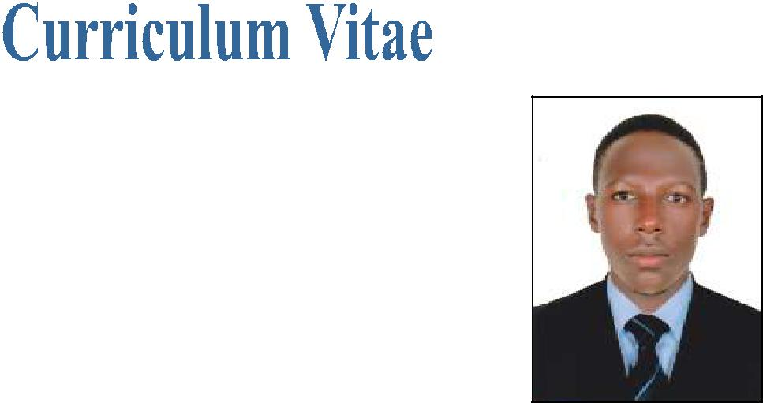

LIVING

E-mail: living.385153@2freemail.com

DUBAI, U.A.E

POST APPLIED FOR : DELIVERY BOY (MOTORCYCLE)

PROFILE

A Suitable position with an organization where I can utilize the best of my skills and abilities that fit to my education, skills and experience a place where an encourage and permitted to be an active participant as well vital contribute on development of the company.

SKILLS:-
- Very Energetic result oriented and organized

- Efficient and well behaved person

- Extremely hardworking self motivated and able to work independently in a team environment under supervision

- Keep excellent inter personal relations with colleagues and ready to help them

PERSONAL INFORMATION

Date of Birth | : | 07/07/1994
Marital Status | : | Single
Nationality | : | Uganda
Visa Status | : | Employment Visa
Languages Known | : | English, Kiswahili and Luganda

EDUCATIONAL QUALIFICATION
- Matric

WORK EXPERIENCE

Presently working as a HELPER with PEARL GARDEN LANDSCAPING LLC, Dubai, U.A.E, Since 10th
June, 2017 to till date.

Worked as a DELIVERY BOY (BIKE) IN UGANDA for 1 Year.

PASSPORT DETAILS

 | Issue Date | : | 13/02/2017
 | Expiry Date | : | 13/02/2027
 | DECLARATION

Here I am kindly declared that the above mentioned details all are true in the best of my knowledge and believe.

LIVING

