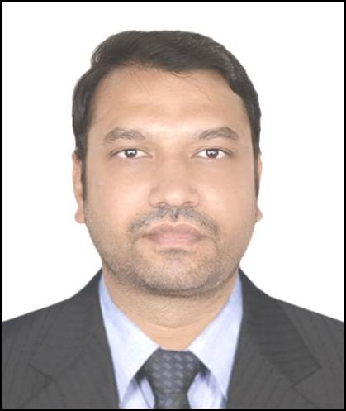
Abdul​​

Email:​​​ abdul.385228@2freemail.com

Address:​​International​​City​​Dubai

OBJECTIVE

A​​suitable​​position​​with​​an​​organization​​where​​I​​can​​utilize​​the​​best​​of​​skills​​and​​abilities​​that​​fit to​​my​​education,​​skills​​and​​experience,​​A​​place​​where​​I​​can​​encouraged​​and​​permitted​​to​​be​​an active​​participant​​as​​well​​as​​a​​vital​​contribute​​on​​development​​of​​the​​company.

SKILLS

- Flexible​​and​​quick​​learner
- Willing​​to​​be​​trained

- Hardworking

- Capable​​of​​working​​under​​pressure
WORK​​EXPERIENCE
- Currently​​working​​from​​1​​​year​​​Marina​​Yaths​​Maintenance​​Services​​as​​Driver

- 1​​year​​work​​experience​​in​​Dubai​​World​​Security​​as​​​Security​​Guard​​in​​Dubai.

QUALIFICATION

- Metric​​passed​​from​​Pakistan.
LICENSE​​DETAILS

Date​​of​​issue | : | 21/12/2016
Date​​of​​expiry | : | 28/12/2026
Place​​of​​issue | : | Dubai​​-UAE

PERSONAL​​PROFILE
Date​​of​​birth | : | ​​​10/01/1985
Nationality | : | ​​​Pakistani
Marital​​Status | : | ​​​Single
Languages | : | ​​​English,​​Urdu,​​Pashto
Visa​​Status | : | ​​​Employment​​Visa
PASSPORT​​DETAILS
Date​​of​​issue | : | 18/02/2015
Date​​of​​expiry | : | 17/02/2020
Place​​of​​issue | : | Nowshera​​,​​Pakistan

CONCLUSION​​AND​​DECLARATION
I​​hereby​​certify​​that​​the​​above​​mentioned​​statement​​is​​correct​​and​​true​​to​​the​​best​​of​​my knowledge​​and​​belief.

