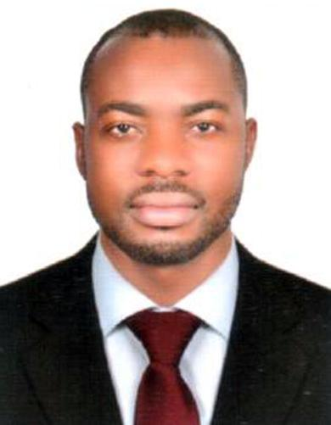
CURRICULUM VITAE

BOBY

Email: boby.385268@2freemail.com
U.A.E

ANY SUITABLE POSITION

OBJECTIVE

To explore and gain experience in various career options, as well as to become well-rounded in various job settings. To become a part of a company’s quest for success where I could render my full support and service as expected from me.

• | Date of Birth | : 11/11/1976
• | Nationality | : Nigerian
• | Gender | : Male
• | Marital Status | : Single
• | Passport No | : A07505851
• | Visa Status | : Job Seekers Visa
• | Language | : English

EXPERIENCE

- Worked as a Security Guard at Helogin Security Services in Lagos, Nigeria (03 years) .

Duties:
- Providing a visible onsite security and deterrent presence.

- Watching out for, reporting and dealing with suspicious or unusual activity.

- Meeting and greeting official visitors.

- Locking up premises and making sure those doors, windows and gates aresecured

- Completing fire alarm and health safety checks.

- Monitoring and Authorizing entrance and departure of employees andvisitors.

- Responsible monitoring and operating CCTV cameras and alarm systems.

- Assisting in administering first aid reporting accident.

- Responding in a timely manner to alarms that have been set off.

- Receiving Mails/Calls from city management and tenants and passing it to the concerned department.

- Dealing with accident and emergencies in a polite, positive and professional manner thereby recording all reports/incidents in the daily Occurrence book.

- Receiving and sending mails respectively from clients and management with the use of Microsoft Outlook.

- Worked as a House Keeping at Hotel Sheraton in Lagos, Nigeria (02 years)

Duties:
- Enters and prepares the room for cleaning.

- Makes bed.

- Dusts the room and furniture.

- Replenishes guestroom and bath supplies.

- Cleans the bathroom.

- Cleans the closet.

- Vacuums and racks the carpet.

- Checks and secures the rooms.

- Replenish amenities according to the operational standards.

- Deliver and retrieve items on loan to guests e.g. iron and ironing boards

- Ensure security of guest rooms and privacy of guests

- Perform rotation cleaning duties (e.g. steam clean carpets, spring cleaning, super cleaning etc.) as required

- Cleans guest bathroom/bed room/floor corridor.

- Responsible for replenishment of guest complimentary water.

.

- Worked as a Cleaner at Full Moon Hotel in Lagos, Nigeria (01 years).

Duties:

- Clean and supply designated facility areas (dusting, sweeping, vacuuming, mopping, cleaning ceiling vents, restroom cleaning etc)

- Perform and document routine inspection and maintenance activities

- Carry out heavy cleansing tasks and special projects

- Notify management of occurring deficiencies or needs for repairs

- Make adjustments and minor repairs

- Stock and maintain supply rooms

- Cooperate with the rest of the staff

- Follow all health and safety regulations

EDUCATION

- Completed National Diploma from Nigeria.

SKILLS

- Organized, Focused and Systematic

- Strong interpersonal and communication skills

- Ability to work with minimal supervision and to grasp new concepts easily.

- Highly principled, Honest, Dedicated and Reliable.

- Good analytical, Organizational and Communication Skills.

BOBY

