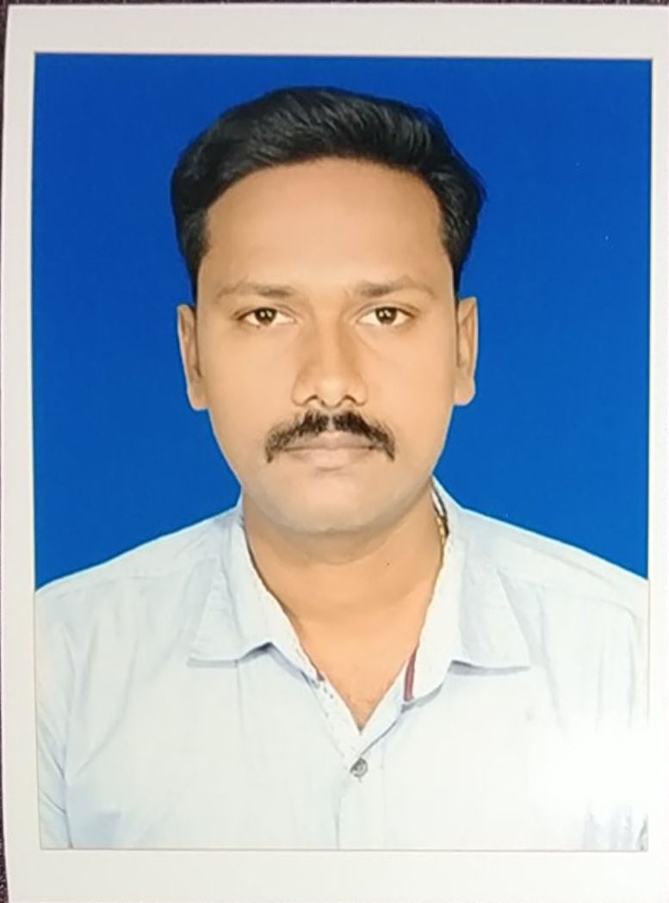
Er. A.SANGEETH KUMAR., M.E(Structural)

Mobile: + 971 547208202 Mail: sangeethcivil2014@gmail.com

Professional Summary

Have 7 Years of Experience in Civil Engineering Projects, involving Drafting in AUTOCAD, Interior & Exterior Designing, Estimation & Costing, Quality Assurance & Quality Control, and Project Management.

Skills

Technical Skills – AUTOCAD, Revit Architecture, STAAD Pro, Total Station, Estimation & Costing(Excel), Quantity Take Off.

Professional Competence

- Experience, Interest & Expertise make me suitable for a position in Civil Engineer Designing. I am eagerly waiting for an opportunity to work in a Company where I can prove my Knowledge.
- Have good experience in Installation, Troubleshooting & Service Support of Civil Software.
- Strong Team Management abilities through task planning, work scheduling, target fixing, delegating, resolving issues, motivating, guiding, mentoring & training the team to achieve excellence.
- Committed Team Player with strong analytical, problem solving, negotiating, communication & interpersonal skill.
- Effective Leadership skills with experience managing teams across Project Management.

Certification

- Licensed Civil Engineer.(India)
- AUTOCAD Certified Professional
- Revit Architecture.
- STADD Pro.

Education

- M.E Structural from Prist University in Year 2017 with Credit 7.41- First Class.
- B.Tech Civil from Periyar Maniyammai University in Year 2014 with Credit 7.45- First Class.
- Diploma in Civil from Dhanalakshmi Srinivasan Polytechnic College, Perambalur in Year 2010 with 75.8% - First Class.
Work Experience

XLNT Construction Managing Director From Feb’15 To Oct’18

Job Profile:
Summary: Perform Engineering Duties in planning, Designing and overseeing Construction and Maintenance of Building Structures and facilities.
- Generated project basis of design documents, edited specifications, and prepared reports for projects
- Perform project management responsibilities on all new projects.
- Mode front-end interactions with clients directly on self managed projects through in-person.
- Develop and manage staff overhead and training budgets.
- Technical checking of work.
- Manage a multi-disciplinary team to complete technical project delivery.
- Use of Creativity in designing and problem solving.
- Implemented safety measures during construction.
      - Identified environmental risks and developed strategies for handling them on each project.
      - Guide managerial and industrial personnel by providing technical advice regarding design, construction, structural repairs, and program modifications.
      - Oversee all construction, maintenance, and operations activities on project sites.

KSM DESIGN ASSOCIATES, Site Engineer/Faculty From Sep’11 To Dec’14

Job Profile:
Summary: Building Plan Creations, Approval Drawings, Elevation Drawings.
- Adopted material optimization techniques. Encouraged construction site staff to reduce the wastage of materials on the field by explaining cost benefits
- Analyzed project-related reports, including maps, blueprints, surveys, and aerial photography.
- Managed and submitted end of month payment invoices to clients
- Determined project feasibility by estimating the quantities and cost of labor, equipment, and materials.
- Trained 120 Students in civil Engineering Software's i.e., AUTOCAD, Revit Architecture, STADD Pro, Total Station.

SIR SAI INTERIOR AND CONSTRUCTION Site Supervisor From Mar’10 To Apr’11

Job Profile:
- Inspect project sites to monitor progress and ensure design specifications as well as safety and sanitation standards are being met.
- Monitored sub-contractors in the completion of daily operations to ensure project progress and optimal performance
- Providing high level support to complete the Project.
- Arranging Work Schedule for Construction workers.

Personal Information

Date of Birth : 24th July, 1992
Sex : Male
Father’s Name : Mr.P.Anbalagan
Mother’s Name : Mrs.Latha Anbalagan
Nationality : Indian
Marital Status : Single
Passport Number : M0310377
Permanent Address : 1/44 North Street, Perahambi(PO),
Mannachanallur(Tk), Trichy(DT),
TamilNadu, Pincode: 621104.
Temporary Address : Industrial Area 13, Sharjah

Declaration

I hereby declare that the information furnished above is true to the best of my knowledge and belief.

Place: Sharjah. Yours Truly

(Sangeeth Kumar. A)

