ASHFAQ

ELECTRICAL ENGINEER
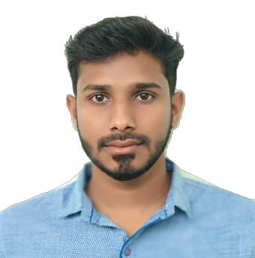

Ashfaq.385723@2freemail.com

HIGHLIGHTS

• Project Management

- Communications skills
• Electrical CADD

- Presentation

• Multi-Lingual

- Organizing skills
• Analytical skills

- DAILux software
• Problem Solving

- PLC Programming

• Strong attention to detail

OBJECTIVE

Unique combination of skills in Electrical Engineering, PLC programming and project management. Ability to quickly assimilate new skills, software and technology. Excellent problem solver, out of box thinker with effective management and leadership qualities. Adept at functioning well both as a team member and independently.

WORK EXPERIENCE

April 2016 – May 2018

SRI SAI PUMPS AND ENERGY SYSTEMS (P) LTD Engineer – Electrical

- Monitored Project progress to ensure accordance with company quality standards for a 60 Million INR Dalmia Cement Bharat Limited Project.

- Troubleshoot all machines are running as efficiently as possible for plant capacity of 18 MW CCP type

- Maintained project status reports by collecting, analyzing, and summarizing information and trends.

- Sound Knowledge in Electrical CAD software in developing Electrical diagram drawings.

- Evaluated electrical systems, products, components, and applications by designing and conducting research programs

- Created and Tested the PLCs for the Manufacturing unit.

- Controlled project plan by reviewing design, specifications, and plan and schedule changes.

- Assured safe and clean working environment by enforcing procedures, rules, and regulations.

- Maintains professional and technical knowledge by attending educational workshops

- Understanding trends and best practices in the buildings industry to meet with World Class Standard

- Maintains product data base by writing computer programs

Key Contribution

Expertly performed preventative maintenance and calibration of equipment and systems, earning outstanding reputation for proficiency and quality.

TECHNICAL EXPERIENECES

- Completed Engineering Final Year project at Bharat Heavy Electricals Limited, Trichy for the duration of four month on the topic MONITORING AND

CONTROLLING OF ELECTRICAL POWERLINE USING MICROCONTROLLER AND SCADA

- Undergone Implant training conducted by Tamil Nadu

Generation and Distribution Corporation at 230 KV Sub Station Alundur, Trichy

- Electrical Load calculations, cable sizing and circuiting (DIALux)

CERTIFICATIONS

- Diploma in Electrical CAD— CADD Center, Trichy, India

- Diploma in Industrial Automation (DIA)–Academic committee of TCIL IT (A Govt. of India Enterprise under Ministry of Communication and

Information Technology) Passed with “A+” grade

- Diploma in Fire and Safety Engineering (DFSE)—Centre for technical and Vocational Development Science (Registered under the Govt. of India)

Passed with “A” grade
- Android Development Program SAP techniversity, Bangalore

EDUCATION

- Bachelor of Engineering in Electrical and Electronics, From Anna University, Chennai, 2016

AWARDS AND RECOGANIZATION

- Awarded as The Best Outgoing Student of Electrical and Electronics department for the year 2012-2016 at M.A.M. College of engineering and Technology

- Got Best Manager title from J.J. College of engineering and technology at
Electrofez’13

- Broken Limca world record for cracking Rubik’s cube along with 1256 student in 20 minute which was previous held by IIT-Mumbai

- Participate and secured 1st Prize in Paper Presentation several time
- Elected as “President of College Student Council” (2015- 16)

PROFESSIONAL DEVELOPMENT

Leadership Nursery Program – NATIVELEAD Foundation, Trichy. Leading School for the training in the field of Project Management and Entrepreneurship. Trained for the duration of 2 Years

Page 2

PERSONAL DETAILS

Date of Birth Present Address Permanent Address Languages Known Location Preference Nationality
Marital

10th December 1994 (23 Years)
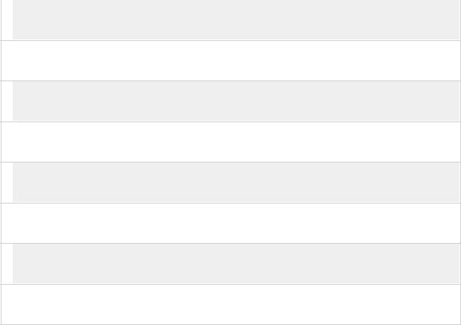
Dubai, United Arab Emirates

Thiruvarur, Tamil Nadu, India

English, Hindi, Urdu, Tamil

Anywhere

Indian

Single

