ABDUL
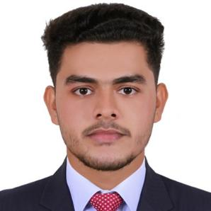
CIVIL ENGINEER, ,
Abdul.385748@2freemail.com

CAREER OBJECTIVE

To utilize my technical background and expertise in civil engineering and provide excellent skills in designing buildings and other infrastructures

EDUCATION

PA COLLEGE OF ENGINEERING

B.E CIVIL ENGINEERING

2018

Navajeevana higher secondary school

HIGHER SECONDARY SCHOOL

2013

Muhimmath high school

SSLC

2011

TECHNICAL SKILLS

AUTO CAD

Ms word, power point presentation and excel
Expert in computer operation
Planning skill
Photoshop
Staad pro(basic knowledge)
MicroStation (basic knowledge)

PROJECTS

Project on self healing concrete | 4 month
A practical project on concrete heals itself by using bacteria.
Extensive survey | 1 month
Surveying the field by different methods
Seminar on CONTOUR CRAFTING | 1 week
The automated construction machine

PERSONAL PROFILE

Date of Birth

: 11-05-1996

Marital Status

: Single

Nationality

: India

Known Languages

: English, hindi, malayalam, kannada, arabic(writing and reading), tamil(speaking and understanding)

Present country : UAE

ACHIEVEMENTS & AWARDS

Participated in cultural activities of the college and school.

Member of event organizing committee of the college.

been volunteer in force,sthapathi, euphoria ( events related to civil engineering).

awarded first in singing competition.

Scholarship

Been good with classmates and lecturers

KEY SKILLS

Excellent Mathematical skills

High level of professionalism
Active listener
Team player
Confident
Quick learner
Designing skills
Creative and innovative mind
Good command over arithmetic calculation
Risk management abilities

PERSONAL STRENGTHS

Communicating: Communication Skills.

Flexibility and Adaptability.
Learning agility: Quick learner.
Tolerance: Stress tolerance.
Critical thinking: Decision making skills.

Creating Ideas: Creativity.

DECLARATION

There by declare that the above furnished information is true to the best of my knowledge.

