CURRICULUM VITAE

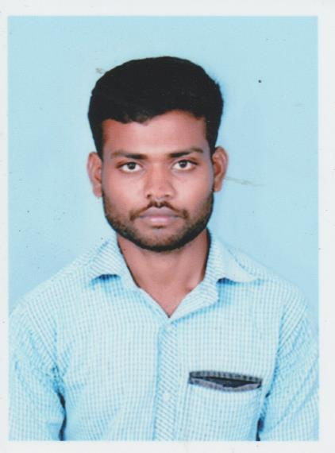
SARAVANA

Email:saravana.385755@2freemail.com

___________________________________________________________

OBJECTIVE

To obtain a good position in a challenging environment to improve my carrier prospects in a higher level and contribute to growth organization and to excel along with the organization in all activities I am hired for
___________________________________________________________________________

WORK EXPERIENCE

- Senior Wealth Manager –KGFS 2014-2016

Job Responsibilities:

- Sourcing business References & lead Generation.
- Meeting customers, identifying needs and providing appropriate solutions.
- Complete Documentation Procedure until Disbursement and Maintaining accounts
- Fraudulent Check & Document Verfication
- Establishing Healthy Relationships and Generating References
- Handling client's queries related with the Products, Meeting entrepreneurs, Business Development, and planning for day to day activities providing financial solution for the customers
- Attending to cold Calls and Meeting Predefined Targets

- Store Keeper –
2016 - 2017

Job Responsibilities:
- To receive and Maintain the stocks supplied by the registered vendors as per the Laid down Procedures.
- Maintaining Proper Records of all Inward and Outward
- Replenishing the stock based on consumptions and To ensure that the stock is always maintained
- To ensure proper stocking of materials by using appropriate method of care and preservation to avoid any damage and loss

ACADEMIC QUALIFICATION

Degree | College / School Name | Year | Percentage
Bachelor of Computer Applications (B C A) | MAHATHMA COLLEGE,PUDUKKOTTAI | 2014 | 67%
Higher Secondary Certificate (H S C) | Government School, Kavarapatti | 2011 | 67%
Secondary School Certificate (S S C) | Government School, Kavarapatti | 2009 | 77%

PROJECTS

- Password guessing attackers using guide click point

STRENGTHS

- Basic of computer (DCA)

- C,VB,ASP.NET, PHOTOSHOP,TYPING

PERSONAL INFORMATION

- Date of Birth 31st July 1994

- Nationality Indian

- Marital status Single

- Languages Known Tamil &English

- Hobbies Reading books, listening music& Playing Games

Place:Dubai
__________________________
Date: ___________________ SARAVANA

