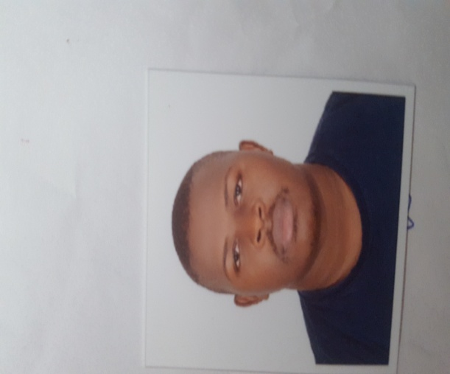
CULLICULUM VITAE
PARSONAL DETAILS
NAME : ELLY
DATE OF BIRTH : 27-APRIL-1993.
SEX : MALE.
MARITAL STATUS : SINGLE.
NATIONALITY : UGANDAN.
PASSPORT NO : B1240804.
NATIONALITY : UGANDAN.
EMAIL : elly.385814@2freemail.com
EDUCATION BACK GROUND,
- 2008-2011 : UGANDA CERTIFICATE OF EDUCATION
- 2013-2014 : UGANDA POLICE TRAINING CERTIFICATE
- 2017 : SECURITY INADUSTRY TRAINING ( SIRA)
WORKING EXPERIENCE,
- PEARL GARDEN L.L.C as data entrant from 2017up to date.
- SPECIAL GAURDING TEAM UGANDA, as team leader 2014-2016.
- ANKRAH HOTEL UGANDA, security supervisor 2014 up to 2016.
CAREER OBJECTIVES.
- Am looking forward to develop my career & experience in security work.
- To grow a strong contribution to the company.
- To be a corner-stone to the company.
HOBBIES AND INTERESTS.
- Playing football.
- Meeting new people.
- Travelling.
- Making research in the surrounding environment.
- Gyming.

KEY COMPETENCE
- Reliable and honest.
- Ability to work as team.
- Strong interpersonal relations.
LANGUEGES PROFICIENCY WRITTING
- English Very good Very good
- Lunganda Good Good

