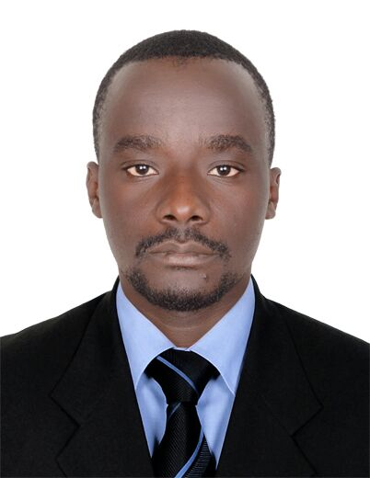
NAME: BUKENYA
ADDREESS: DUBAI, U.A.E
VISA STATUS: EMPLOYMENT VISA
EMAIL ADDRESS: bukenya.385859@2freemail.com

Professional Summary
An experienced Waiter and customer care service executive with Serena Hotel Uganda for 3 years. I am a result oriented and self-driven person who works well within a team and often contribute ideas to improve working practices. In addition, skilled in monitoring ,planning, management and able to work in a multicultural and multi-disciplinary environment, with good judgmental, initiative, high sense of responsibility and leadership.

Professional experience

Serena Hotels (Uganda)
Position: WAITER
Duties and Responsibilities;
- Providing excellent wait service to ensure customer satisfaction.

- Taking customer orders and delivering food and beverages.

- Making menu recommendations and answering questions from the customers in order to reach customer satisfaction.

Sharing additional information with restaurant patrons inorder increase the quality of services offered and improving customer relations.

Professional skills

Business analysis

Learning and development

Leadership and team dynamics

Conflict resolution

Professional Training and Certification
- Bachelor of Business Admistration - Ndejje University (Uganda)
- Certificate in Hotel management –YMCA(Uganda)
- Certificate in IT
- Bachelor of Marketing and Sales –Ndejje university(Uganda)

