 |  |  | Cynthia
 | Personal Details:
 | Address: |  | Dubai, UAE
 | E-mail: |  | cynthia.385937@2freemail.com
 | Sex |  | Female
 | Date of Birth: |  | 21st November 1988
 | Status: |  | Single
 | Visa Status: |  | Visit Visa
 | Profile |  | Energetic and dedicated HR cum Admin assistant who is able to work as part of team and
 |  |  | manage several priorities at any one time. Holder of a BSc in Biochemistry, with Dubai (U.A.E)
 |  |  | experience in a multicultural environment. Dynamic, outgoing, professionally dependable and
 |  |  | detail oriented with sound experience attending to clients, customers, associates and other
 |  |  | callers.
 | Academic Qualifications:
 | 2013 |  | BSc. In Biochemistry (Specialty: Clinical Biochemistry): University of Dschang, Cameroon
 | 2006 |  | LCHS Mankon: GCE A/L
 | 2004 |  | GHS Bafut: GCE O/L
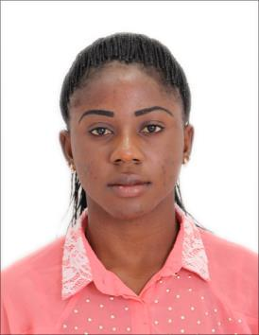

Experience:

Sept 2016 – Nov 2018

Nov 2013 – Dec 2015

Admin Assistant cum HR Assistant : Big Boys Interiors Design LLC, Dubai, UAE Duties:

- Acting PRO liaising with various government departments (Civil defense, Dubai Municipality, Ministry of Human Resources, Immigration and RTA) when necessary for efficient day to day company activities

- Kept track and arranged documents for medical tests, emirates ID to ensure timely issuance/renewal and cancellation of labor cards, and residence visas

- Prepared final settlements and leave settlements in accordance with MOHRE policies

- Acted as first point of contact for anyone enquiring about a vacancy and scheduled interviews

- Prepared and edited documents including Offer letters, Bank letters, Disciplinary letters

- Coordinated all company renewals such as medical insurance, vehicle Registration, Public Liability, Project insurances, Trade License and Tenancy contracts

- Filed documents and HR records both electronically and in hard copies

- Adhered to office policies especially regarding confidentiality

- Scheduled meetings, appointments and travel arrangements for management/employees

- Welcomed guests courteously, answered phone calls/emails and rerouted to relevant parties

- Maintained attendance and overtime records for workers

- Monitored and placed orders for office stationery

- Performed other clerical duties as assigned and general office work including maintenance and repairs

Customer Service agent for Nexttel, North West Region Cameroon Responsibilities
I received calls, attended to clientele complains, sold directly to clients, gave directives and educated clients on new products and usage, gave feedback to management.

 |  | Internships |  | Lab Technician: Hope Services Clinic, Yaounde , Cameroon– June 2012 to July 2012
 |  |  |  | Lab Technician: Presbyterian Health Centre, Bafut – April 2014
 |  | Computer Skills |  | MS Office: MS Word, MS Excel, MS Power Point
 |  | Languages |  | English & French
 |  | Interests |  | Reading professional magazines/news papers, Music

