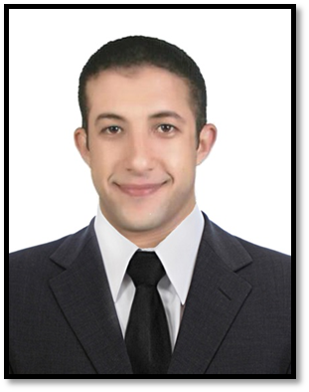
Ahmed
Dubai, UAE
E-mail:ahmed.385967@2freemail.com

Objective
An Architectural Engineer seekig employment in organization where i can use my knowledge, skills for the progress of the work and try to achieve its targets.
I have effective communication skills, planning, flexibility, work hard, work under pressure and work with a team.

Work Experience ( oct. 2017 to oct. 2018 )
Site Engineer
For Alfursan Construction & Contracting in Social Housing projectin 6 octobrgardens .

Responsibilities:
• Prepare the work requirements on daily & weekly basis.
• Follow-up distribution of work to supervisors.
• Ensure the execution of work according to quality standards.
• Follow-up the performance rate and Quantity Survey for the implemented tasks
• Manage the subcontractor performance & quality of work.
• Manage the coordination with technical office.
• Review the Subcontractor Interim Payment according to their achievements.
• Apply the Health & Safety regulations.

Education
B.SC. Degree in Architecture Engineering 2012-2017
From Misr Higher Institute for Engineering & Technology in Mansoura, Egypt.
General Grade: GOOD
project Grade: VERY GOOD

Skills&Competencies
Computer skills
- AutoCAD 2D
- Rivet Architecture
- Adobe Photoshop
Languages
- Arabic : MT
- English : Good
Artistic skills
- Photography
- Maquette
Personal skills
Quick learner with effective communication skills & the ability to workunder pressure,
adapting with different managements, Flexablity, Multi taskingablity Capable of finding out
solutions, cooperative work with a team .

Personal Information
Date of birth : 1 / 9 / 1993
Gender : Male
Nationality : Egyptian
Marital status : Single

