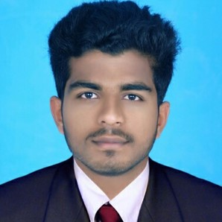
ABDUL

|
Abdul.386297@2freemail.com

CAREER OBJECTIVE
Mechanical Engineering graduate seeking a position in an organization where I can display my technical abilities and knowledge to contribute for the growth of the organization simultaneously helping me to fulfill my carrier objectives and widen my knowledge.
EDUCATION | Course University/Board Year Percentage  B-Tech, Mechanical Engg Kannur University, Kerala Aug 2014 - Aug 2018 69  12th Board of Higher Secondary Examination,Kerala Aug 2012-Apr 2014 87  10th Board of Public Examination, Kerala 2012 88
SKILLS | AutoCAD  MS Office  Time Management  Team work  Confidentiality  Communication skill  Problem solving  Critical thinking
ACADEMIC PROJECTS | Design of hydrogen blended hydrogen gas fuel engine. 90 days  The main objective of the project is to reduce the emissions from the automobiles. The main reason is this does not emmit Green House Gases. By the usage of hydrogen cost can be reduced. Blending the hydrogen gas with ethanol ensures reduced emmission and reduces the cost compared to the existing fuels. Ethanol is used as a substitute of gasoline, which can be produced from biomass which is renewable.  Efficiency improvement of refrigeration using nanofluids. 90 days  The main objective of the project is to reduce the energy consumptions and to increase the efficiency of the refrigerators. The concept of the project is based on the fact that solids have high heat capacity as compared to a fluid. So nanoparticles are dispersed into a base fluid inorder to enhance physical properties of base fluid The usage of nano fluids in vapour compression refrigeration system causes reduction of evapourator area and pressure drop is reduced while compared to the conventional coolants.
ACHIEVEMENTS & AWARDS | First in district level Maths fair conducted by Kasargod district Maths club association.  First in sub district level Maths fair.
^{INDUSTRIAL TRAINING}
Underwent 5 day industrial training at KSRTC regional workshop, Mavelikkara.
INTERESTS | Production  Product design
PERSONAL PROFILE | Date of Birth  Marital Status | : 08/10/1997  : Single
 | Nationality | : Indian
 | Known Languages | : English,Hindi,Malayalam

ABDUL

