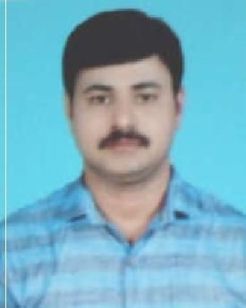
Satheesan

Email: satheesan.386446@2freemail.com

■SUMMARY

Seeking challenging career in a quality environment where my knowledge and experience can be shared and enriched looking for the opportunity where I can improve my skills bringing out thhe best of my talent and my effort

  - SKILLS

- Understand processes behind patrolling commercial and industrial properties as well as private homes and

neighborhoods.

• Ability to work independently with minimal supervision • Ability to lift and move heavy objeects • Strong organizational skills with an eye for details • Good cleaning and sanitation skills • Housekeeping • Good interpersonal and oral communication skills • Is a good team member • Knowledgeable about food safety standard

Watch man 5 Years

- Patrol the premises and adjacent arreas

- Performs patrol duties within assiggned areas to guard against theft, shoplifting, vandalismm, and fire

- Perform safety inspections in ordeer to flail off any negative activity

- Check identity cards of personnel before admitting into the building

- Take necessary action on spot when needed

- Prepare detailed reports and records

BIN SAFAR PRO PERTY IVESTMENT DUBAI

Store Keeper 2 Years

DUBAI CLENING COMPANY Housekeeping 1 Year

DUBAI

■EDUCATION

PRE DEGREE

HIGH SCHOOL

■ PERSONAL DETAILS

Nationality | : | INDIA KERALA
Date of Birth | : 18-05-1979
Sex | : | Male
Marital Status | ; | Married
Languages Known | : | English, Hindi,
.

■DECLARATION

I here by declare that the above-furnished details are true to the best of my knowledge and belief and nothing has been concealed

Satheesan

