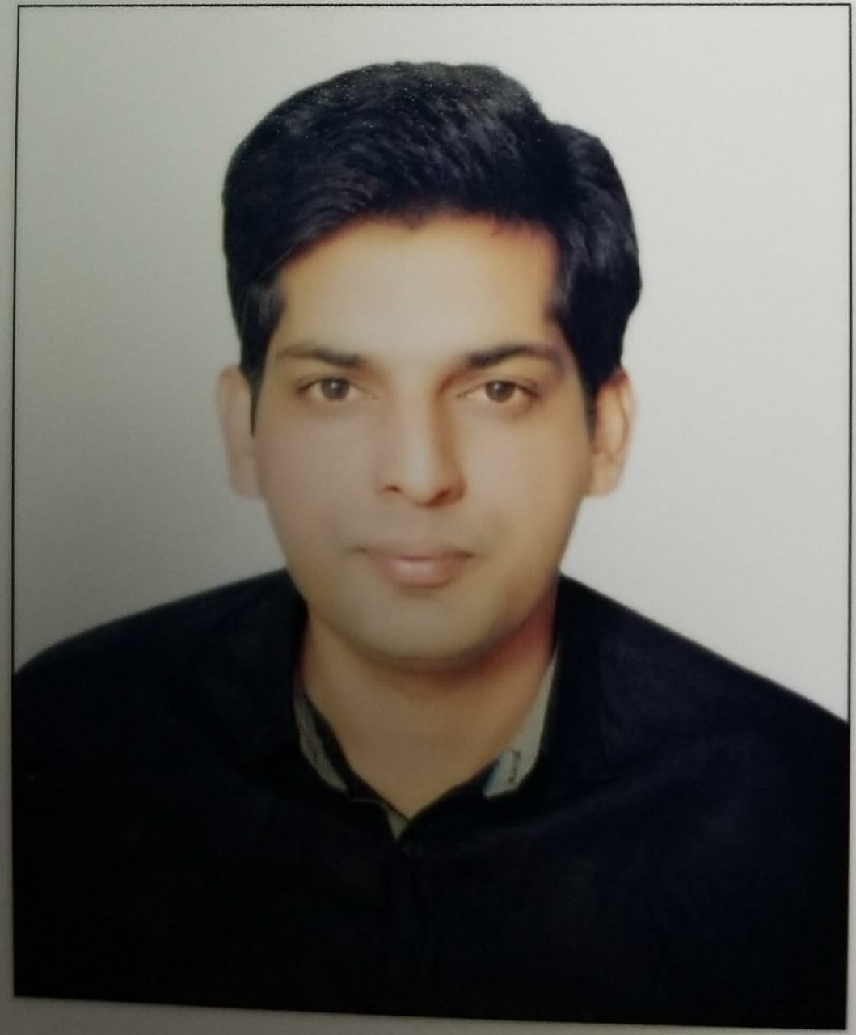
MUHAMMAD FAIZAN RASOOL

Email: muhammad_386496@2freemail.com

Career Objective
A highly engaged and positive team player with a strong customer focus and the motivation to deliver exceptional sales results.

Key Skills
- Sales Management
- Product communication
- Sales of building materials
- Highly motivated and target driven.
- Ability to create and deliver presentations tailored to the audience needs.
- Able to understand customer’s needs.
- Able to acquire technical product knowledge and combine them into a solution
- Documentation
- Strong organizational and time management skills.
- Ability to search and generate new leads when needed.
- Seek for continuous improvement ideas.
- Working in diverse environments.
- Communicating and presenting data effectively.
- Excellent selling, communication and negotiation skills.
- Using the computer and its application.
- Good at Ms office
- Resolving problems in an efficient manner.
- Managing stressful situations and projects.
- Able to work independently and a good team player.

Work Experience

Sales Executive (November 2016 – October 2018)
Responsibilities:
- Present, promote and sell products using solid arguments to existing and prospective customers.
- Plan and divide geographic area in order to cover it within an agreed timetable.
- Sales of billets, Reinforcement steel bars of quality Gr.60, Gr.40 of different sizes.
- Identify new markets and business opportunities by determining prospective clients and evaluating their position in the market.
- Research and analyzing the different sales options/suggestions to be given to the client.
- Manage & maintain relations with customers, channel partners & colleagues.
- Participate in face to face meetings and introduce company services.
- To ensure that the response to any business request is auctioned within 24 hours.
- Identify product improvement.
- Collecting information on various tenders in the market and provide to senior sale manager in order to decide on next steps.
- Handle complaints and pass it on to Senior Sales Manager.
- Update client information in company database.
- Prepare reports by collecting, analyzing and summarizing information.
- Monitor and develop daily/weekly reports
- Maintain quality service by establishing and enforcing organization standard.
- Work closely within the Sales and Presales team as well as other company’s divisions to deliver a complete solution for the client.
- Identify business opportunities, business prospectus and evaluation their position in industry.
- Attending trade exhibitions, conferences and meetings.

------------------------------------------------
Sales Executive ( August 2012 to November 2016)
New Shalimar Steel Industries (Pvt) Ltd.
Lahore, Pakistan
Responsibilities:
- Handling the sales & marketing function activities.
- Sales of Billets, Round bars, square bars, Angles, channels and H-beams, I beams.
- Meeting the sales targets.
- Ensure customer satisfaction.
- Focusing on collecting information regarding competitors activities and new trends in the market
- Provide support, information, and guidance to existing and prospective customers
- Responsible for planning forecasting and implementation of sales plane.
- Achieve the sales target by using advanced sales techniques and product knowledge.
- Attending meetings with potential customers and closing sales.
- Prepare and perform product demos and company presentations
- Building a sales pipeline to ensure a constant stream of sales.
- Document sale by creating or updating customer profile record.
- Complete daily sales, weekly and monthly reports.
- Monitoring competitor activity and competitors' products.
- Understanding of Production process.
- Maintain professional and technical knowledge by reviewing professional publications related to the industry, new products, latest market trends and competitors’ position in the market.
- Marketing activities through providing brochures to companies, exhibitions

Academics
Qualification | Institution
B.Sc. Metallurgical & Materials Engineering | University of Engineering and Technology, Lahore

Languages
- English – Full Professional Proficiency
- Urdu – Native / Bilingual
- Punjabi – Native / Bilingual

