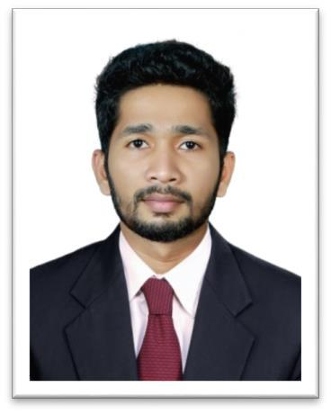

ABOUT ME

Date of Birth:

January/10/1995

Age: 23

Nationality: Indian

Sujay_386830@2freemail.com

TECHNICAL SKILLS

- AutoCAD Electrical 2016

- Revit MEP

- Computer skills : MS Word, PowerPoint, Excel

- Programming Languages: C++,Matlab

S U J A Y

Electrical Engineer

CAREER OBJECTIVE

To be part of a highly motivated dynamic organization where I can apply my knowledge, technical expertise and managerial skills for the rapid development of the organization.

ACADEMIC CREDENTIALS

BTech in Electrical&electronics Engineering from Axis College of Engineering & Technology affiliated to University of Calicut, Thrissur, Kerala, India.

WORK EXPERIENCE

Electrical Supervisor (October 2017-

0ctober2018)

A Grade Electrical Manufacturers & Contractors, Industrial Development Plot, 56 B1, Peringandoor P.O., Athani,Thrissur,Kerala-680301

Experienced in Installation & Commissioning of complete electrification works of High-rise building, Industries & Villa projects.

Job Responsibilities:-

- Supervision of HT & LT Electrical works such as Termination of cables, Lighting & Earthing system installations, Cable dressing & glanding, Electrical conduit works,Cable tray work,

- Testing of installed Electrical Systems and maintenance.

KEY SKILLS

- Adaptability.

- Ability to Work Under Pressure.

- Decision Making.

- Time Management.

- Self-motivation.

- Good communication skills.

.

- Ensuring that all the works done are in accordance with the approved construction

drawing, contract documents, project specifications, and all applicable standards

- Daily & Weekly work Progress Report Preparation.

- Manpower controlling & problem solving

WORKSHOP/ SEMINARS ATTENDED

- Attended 7 days internship under Kerala State Electricity Board.

- Visited and studied the functions and operations

Hydro Electric project in KSEB Malankara,Thodupuzha, Kerala,India.

- Presented a seminar on “A Novel Approach For Transmission Line Fault Detection Using Synchro

Phasor Measurement” during the academic year.

- Participated in a Seminar organized by Axis College of Engineering & Technology on SMART SYSTEMS on 18th Sep 2015.

EXTRA CURRICULAR

- Active member in National Service Scheme during the academic years which include social works.

- sports captain of college.

- Participated in the tournaments conducted by Kerala State Football Association representing Thrissur District in Junior and Sub-junior categories.

DECLARATION

I hereby declare that the information furnished above is true to the best of my knowledge and I bear the responsibility for the correctness of the above mentioned particulars

SUJAY

