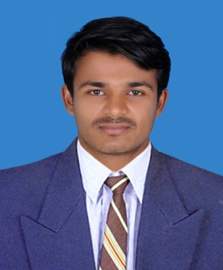

CURRICULUM VITAE

REDDY
E-mail: reddy.386949@2freemail.com

OBJECTIVES

Hard working graduate with proven 2 years of experience in accounting department leadership and organizational skills seeking to apply for more informative and interactive atmosphere where the Organization encourages me to give the Level Best of my Hard Work, Sincerity and Loyalty. And also to get an Opportunity to Utilize, Enhance and contribute my Expertise and Experience

EXPERIENCE

- Worked as an Accountant from Two Years.

JOB PROFILE

- Identifying business transactions with documentary proofs
- Entering the identified business transactions in tally like Purchases, Sales, Purchase Returns, Sales Returns, Expenses, Incomes, Assets & Liabilities
- Checking each & every account in Ledger regarding accuracy & posting
- Preparing entries for accrued expenses when they are incurred
- Verifying bank statements everyday through online
- Finding mismatch transactions in cash book and pass book
- Preparing BRS to equalize cash book balance to pass book balance
- Preparing Purchase Order for Required Goods
- Verifying purchase order with invoice and DC(3 Way Matching)
- Checking the condition of Received good
- Processing Debit Note for Purchase Returns.
ACADEMIC CHRONICLE

- B.COM in Telangana University in 2011 - 2014

- MBA in Jawaharlal Nehru Technical University in 2014 - 2016

PERSONAL SKILL AND ABILITIES

- MotivatingandEncouragingSkills

- Ability toWorkIndependently

- GoodCommunicationSkills
SKILL TEST

- Tally ERP9.0

- M.S Office-2003, 2007 & 2010

- Operate in windows xp,7,8,10

- Well versed with internet and E-Mails
LINGUISTIC ABILITY

- English ( Read write and speak)

- Hindi (Read write and speak)

- Telugu (Read write and speak)

PERSONAL DETAILS

Nationality : Indian

Date of Birth : 05/05/1993
Marital status : single

DECLARATION

I hereby declare that the information and details furnished above are true to the best of my knowledge and beliefs.

