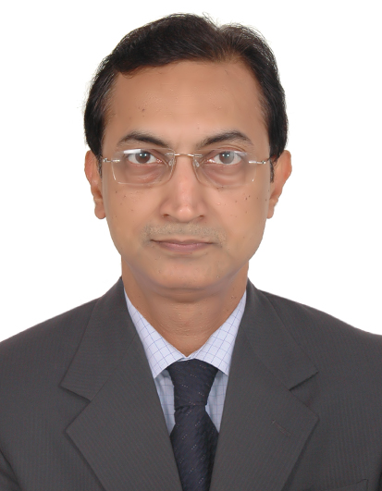
Monilal
Email: monilal.386972@2freemail.com

Synopsis | - Senior Training Instructor &Competence development specialist  - Chemical Engineer, certified competence Assessor & Verifier  - 30 years of Experience in 6reputed ‘Oil and Gas’ companies -  16 years in Training(7 years in Gulf) and 14 years in plant Operation  - Expertise in highly effective Training & Development;Focused on Leadership, Coaching& Team building;being logical Thinker,Innovative, Flexible, with commitment & integrity.
Education  Qualifications  Skills & Capabilities  Experience  PreviousEmployers | - B.Tech. (Chemical)in 1987(3rd Rank) &B. Sc. (Honors in Chemistry) in 1984 –  both from the University of Calcutta, India.  - Post Graduate Diploma in Ind. Safety & Occupational Health – SJISMS, India.  - 9Di Competence Assessor, certified by S.Q.A.(Scottish Qualification Authority).  - L&D11 Competence Assessment Verifier, certified by S.Q.A.  - Certified in ‘Creative Training techniques & Best Practices’(Train-the-Trainer) inATD (Association for Talent Development) Conference, USA.  - Certified in ‘Evaluation of Training Effectiveness’ by ISTD, India.  - Six Sigma Black Beltfrom ISI, India - on ‘Improving Learning Effectiveness’.  - BVQI certified ISO 9001/14001/18001 Auditor.  - Contributed to Training &Development in GPIC-Bahrain & Reliance-India, to Win four ATD BEST Awardsin 2006/2008/2010/2012, & to Win IFTDO Global HRD Award in 2006.  - Certified in ‘Managerial Effectiveness’ by Welingkar Institute(India), ‘Change Management’ by Symbiosis Institute (India), ‘advanced Microsoft Windows’ by IBM Corporation (India).  - Rich expertise in designing, planning& executingCompetence basedTraining & Developmentsystem forTrainees/Employees in Oil and Gas plants,to develop Technical/HSE/IT/Soft skills.  - Competence Assessor & Verifier;Talent managemente.g. Recruitment Test & Interview.  - Led a Training team in Reliance-India, to design & implement Training planfor Leaders, Managers, Supervisors, Operators& Contractors.  - Expertise in designing Training programs& creating Training Contents as per Learning needs, &‘On-jobRefinery Operation’ training/ assessment of Shift Supervisors/Sr. Operators/Operators.  - Major role in Company-wide Training on Process Safety & Workplace Safety, in association with Dupont Safety Resources experts (USA).  - Management of Simulators,e-Learning/e-portal, Discussion forum, Virtual training.  Job profile as SeniorInstructor(Acting Team Leader) :  - Leading a team of Training Instructors, in Refinery Technical/HSE training/Competence Assessment of 340 Trainee Operators/Technicians/Supervisors (YDP- Youth Dev. Program).  - Designing & implementing learning & development strategy, in coordination with Refinery line management & corporate Talent Development division.  - Orchestrating Learning Needs Analysis for nearly 3000 employees in ADNOC Refining.  - DesigningTraining KPI/guidelines&developing Standardized training contents as per Employees’ identified Learning needs.  - Delivering Technical courses– Process chemistry, Crude oil Distillation, Naphtha/Kerosene/LGO Hydrotreater/Hydrocracker, Vessels, Heat exchangers, Furnace, Pumps, Compressors etc.  Gulf Petrochemical Industries Company (GPIC), Kingdom of Bahrain  (Nov 2011 to Jul 2014) - Job profile asTraining Instructor :  - Technical/Safety training&CompetenceAssessment of Graduate Engineers& Plant Operators in Ammonia &Methanol plant operation; Learningneeds analysis &development through Competency development system in SAP-HR.  - Training management with the help of Simulators & API modules; Administration of e-Learning modules &Knowledge management initiatives.  - Technical inputs to Manpower planning & budgeting, Online Test & Interview for Recruitmentof Graduate Engineers & Operators.  - ‘Process Safety Management’ training for all employees & ‘HSE Induction’training for New employees; Development of state-of-the-art Training manual for Methanol plant.  Reliance Industries Limited (RIL), Patalganga&Nagothane, Maharashtra, India  (Jun 1997 to Oct 2011)- Job profile asGeneral Manager, Training & Development :  - ImplementedTraining& Development systemfor 2050 employees (Leaders, Managers, Supervisors, Operators&Contractors),for developing Technical/HSE/IT/Soft skills.  - Designed & executed Competence development & Assessment system&implemented Annual Training Plan, based on identified Learning needs.  - Developed L&D standards, guidelines, processes & contents as per global Best practices.  - Directed Company-wide Trainingon Process Safety & Workplace Safety, being active memberin Dupont (USA) Safety Training & Audit committee.  - Created & managede-learning, Simulators, Discussion forum, Structural Capital &Library initiatives; developed Interactive e-modules.  - Managed Training system for Graduate Engineers&Management Trainees; Implemented Mentoring scheme&Evaluation,in association with Hewitt Associates.  Earlier workedas Manager in Paraxylene plant Production, DCS operation ofNaphtha Hydrotreating, Platformer, CCR, Isomar, Tatoray & Adsorptionunits; involved in production planning, reliability, troubleshooting& optimization,meeting safety/environment & quality norms, energy & safety audits, hazards identification& risks assessment, preparation of SOP.
3.. | Ispat Industries Limited,Maharashtra, India  (May 1993 to May 1997) - Job profile asAssistant Manager :  Commissioning & Production in Natural gas Reforming/DRI plant, withWorld’s largest Reformer, optimization ofenergy & process parameters, prod.quality norms, troubleshooting.  Fertilizers & Chemicals Travancore (FACT) Ltd, Kerala, India  (Mar 1989 to Apr 1993) - Job profile as Process Engineer:  Commissioning, Production & debottlenecking of DCSoperated Caprolactam plant, with Hydrogenation, Oxidation& unit operations;involved in troubleshooting, energy optimization.  Hindustan LeverLimited, West Bengal, India  (Jun 1988 - Feb 1989) – Job profile as Graduate Engineer :  Production/Troubleshooting insulphuric & phosphoric acid plants, supervising operational activities, coordinating with maintenance dept., optimizing energy &process parameters.

