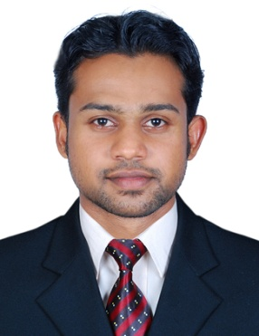

ADEWALE

Profession Seeking : CLEANING
Language : English
Email : adewale_387120@2freemail.com
Visa Status : Visit visa

CAREER OBJECTIVE
To seek a challenging position in your company with opportunity & growth that would best fit my qualification and develop further my talent & skills for continues career improvement.
Objective is to work in an exciting and professional environment of the organization with personal development and growth possibilities and to achieve company’s goal through professional ethics, sincere commitment and hard work.

Profile SUMMARY
- Have the ability to quickly identify problems as well as provide appropriate solutions.
- I am also very hard working and always ready to go beyond job basic requirements whenever necessary.
- I am a positive person with good character and get along well with people in all situations.

QUALIFICATION

- SSLC
- DIPLOMA

WORK EXPERIENCE

- ORIENTAL HOTEL, NIGERIA : ONE YEAR EXPERIENCE

DUTIES & RESPONSIBILITIES

- Cleaning of environment
- Take order from patrons for food and beverage
- Greeting customers who enter the hotel
- Answering queries from customers

PERSONAL INFORMATION

Linguistic Abilities : English
Date of Birth : 25-02-1997
Gender : Male
Religion : Christian
Marital Status : Single
Nationality : Nigeria

DECLARATION

I hereby declare that the above information is correct up to my best of knowledge and
Belief.

