CURICULUM VITAE

CAREER OBJECTIVE

EDWIN
Personal profile
DOB 07/06/1994
Gender Male
Nationality Indian
Marital Status Single
E-mail
Edwin.387430@2freemail.com
Languages Known
English, Hindi, Malayalam,

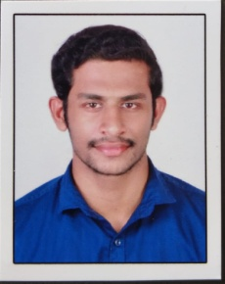
Seeking a challenging opportunity to work with commitment and passion in an esteemed firm to make sincere contributions in achieving the company objectives and at the same time where I can improve my skills and abilities
ACADEMIC CREDENTIAL

M.COM FINANCE FROM WISDOM COLLEGE
PAVARATTY BHARATHIYAR UNIVERSITY 2015-2017

B.COM FINANCE from CO-OPERATIVE COLLEGE THRISSUR (Affiliated to Calicut University) (2011 – 2014)
OTHER CERTIFICATE COURSE

- TALLY
- PEACHTREE
- EXCEL

Work Experience

- Worked as credit verification officer (cvo) at indusind bank pvt ltd for the past two year

RESPONSIBILITY
- Approve loans within specified limits, and refer loan applications outside those limits to management for approval.
- Meet with applicants to obtain information for loan applications and to answer questions about the process.
- Analyze applicants' financial status, credit, and property evaluations to determine feasibility of granting loans.
- . Explain to customers the different types of loans and credit options that are available, as well as the terms of those services.
- Obtain and compile copies of loan applicants' credit histories, corporate financial statements, and other financial information.
- Compute payment schedules.
- Set credit policies, credit lines, procedures and standards in conjunction with senior managers.

Work Skills
- Adaptability
- Planning , scheduling and monitoring
- Effective Team work
- Time management. Good time-management skills go hand-in-hand in with strong organizational capabilities. .

PERSONAL SKILLS
- A self-motivated and positive in nature
- Believes in efficient way of working
- Committed to the responsibility

