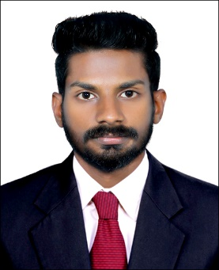  ABOUT ME  A strong pro-active talented professional with over 4 year considerable experience.  SPECIFIC PROFICIENCIES  - A dynamic and multitalented professional with exceptional financial knowledge having degree of MBA.  - Able to handle multiple task simultaneously.  - Excellent utilization of all resources.  - Strong organizational skills, detail oriented, and the ability to handle multiple priorities.  HOBBIES | RANJITH  MBA – FINANCE & HR  CAREER OBJRCTIVE  Looking a challenging position in an organization where I could develop my skills fostered. Strive to play active role in a team with an objective of contributing to the potential growth of the company and its immense strength considering timing and competitive environment and I shall breathe my work provided with pleasant and friendly work atmosphere, with creative freedom to prove myself.  CAREER SUMMARY  Senior Accountant 2018 – Present  Forever Travel  Assistant Accountant 2014 –2015  Stepping Stone Accounting Consultancy  Admin Cum HR Executive 2012 –2014  IT SKILLS  Accounts Management Inventory Management Tax Management Payroll Management MIS Reporting Tally. ERP 9.0 Peachtree QuickBooks MAYOB SAGE 50 MS. Office SAP Training  PROFSSIONAL AND TECHNICAL QUALIFICATION  Bachelor of Business Administration (BBA) University of Calicut 2012 Post Graduate Diploma in Indian and Foreign Accounting (PGDIFA) IPA 2014 Master of Business Administration (MBA) Bangalore University 2017 SAP Training – Financial management – FI Connaissance 2017  IVS Solutions  LANGUAGES KNOWN  Proficient  English Malayalam  Hindi Tamil  PROJECTS DONE  Project from : Keratech coconut oil manufacturing company PVT.LTD  Project Title : Financial statement analysis at Keratech coconut oil Manufacturing Company PVT.LTD  JOB RESPONSIBILITIES HELD  Accounts Task  - Computerized the accounting system that replaced manual ledger.  - Preparation of monthly administration expenses statement and related reports.  - Ascertain the requirement of cash for the month and arrange cash from the bank.  - Assisting management in the preparation of policies and procedures for accounts department.  - Cerate, sent and follow up on invoices.  - Handling petty cash.  - Review and audit financial statements and reports to ensure and data entries are correct.  Admin Cum HR Executive Task  - Establish a record of management system for the guidance of project staff, consultants.  - Maintain files of all personnel, consultants actively engaged in project.  - Prepare and arrange travel plans including visas, transportation & accommodation booking for project staff, consultants and invited guests for project activities & procurement plans for the project.  - Proven track record in project management such as in meeting deadlines, timely submission of acceptable deliverables, etc..  - Knowledge of the atlas or any system similar to people software.  - With satisfactory skills on the use of office software package such as MS. Office and Accounting Software.  PERSONAL INFORMATION  Date of birth : 09/01/1992  Gender : Male  Marital Status : Single  Nationality : Indian  Religion & Cast : Hindu, Ezhava

