RESUME
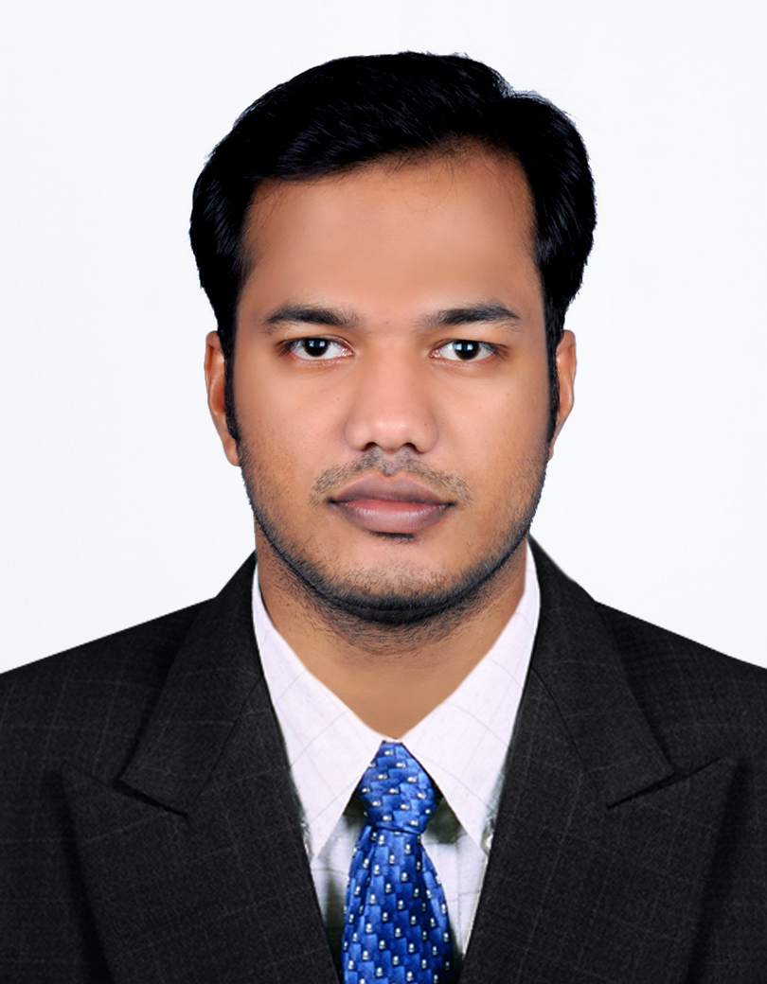
RANJITH
Email: ranjith.387448@2freemail.com

CAREER OBJECTIVE:
I would like a career that gives me rich exposure through diverse assignment and working with people of high caliber. I would constantly look out for challenges, which would help me to achieve my personal and professional goal.
EDUCATIONAL QUALIFICATION
COURSE | INSTITUTION | BOARD / UNIVERSITY | YEAR OF PASSING
MBA  ( HR & MARKETING ) | Nehru College of Engineering & Research Centre, Thrissur | University of Calicut | August 2016  ( Completed )
BBA ( HR ADMIN ) | Co-operative college, Thrissur | University of Calicut | March 2014  ( 55.25% )
PG DIPLOMA ( BUSINESS ADMIN ) | Annamalai University | Annamalai University | June 2018  ( Passed )
DIPLOMA ( HEALTH INSPECTOR ) | Farook paramedical institute, Calicut | Govt of Kerala | March 2010  ( 80% )
PLUS TWO | G.V.H.S.S,  Ayyanthole | Govt of Kerala  (State Board) | March 2008  ( 72.25% )
SSLC | ST.MMC.HS,  Kanipayyur | Govt of Kerala  (State Board) | March 2006  ( 71.05% )

TECHNICAL SKILL
- Basics of MS OFFICE
- DIFA
- Photoshop

WORK EXPERIENCE
HR Administrator at Westfort Hospital, Thrissur, Kerala, India (February 2017 – May 2018)
Duties & Responsibilities
- Ensuring timely initiation & proper compliance of statutory requirements (PF,ESI)
- Recruiting of workmen as per the selection procedure specified.
- Shortlist CV s and arrange interviews
- Provide proper recruiting and training to staff
- Define job description of employees
- Maintain new appointments and resignation
- Update registers like leave registers, holiday wage register and attendance register
- Maintain proper files for all staff and follow up with files new joinees.
- Arrange performance appraisal of employees after 1 year
- Maintain details regarding employees transfer, promotion, and termination
HR Executive at TRIOs Development Support (P) Ltd, New Delhi, India (April 2014 – November 2014)
Duties & Responsibilities
- Work with company CEO and/or Director to strategically plan HR initiatives that will benefit the company and encourage more efficient and beneficial work from employees
- Direct all hiring and training procedures for new employees
- Administer or change benefits, health plans, retirement plans, etc.
- Monitor employee progress and stay abreast on company climate and culture, ensuring it stays positive and productive
- Coordinate and direct work activities for managers and employees
- Promote a positive and open work environment where employees feel comfortable speaking up about issues
Sales Officer at HDFC Bank Limited (Sustainable Livelihood Initiative) Thrissur, India (August 2016 – January 2017)
Duties & Responsibilities
- Finding out Kudumbasree, Self Help Group and all other customers through regular visiting.
- Provide proper loan related classes to all clients
- Selling of banking products to clients. Products might include either Credit Cards, Mortgage, Loans, or all of these.

- Prospecting and identifying new leads and pitching to the clients.
- Providing client service to existing customers.
- Answer all lead and customer questions accurately; prioritize and/or escalate lead and customer questions as needed
- Maintain positive business and customer relationships in the effort to extend customer lifetime value
PERSONAL DATA
- Name : Ranjith
- Age : 27
- Date of Birth : 11/04/1991
- Gender : Male
- Marital Status : Unmarried
- Nationality : Indian
- Language Known : English, Malayalam & Hindi,

