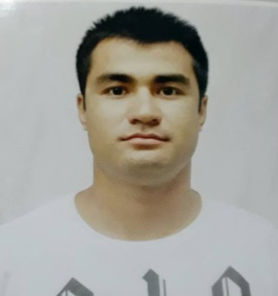
Mishan
EMAIL ID: mishan.387451@2freemail.com

Objective I am a friendly and outgoing costumer service officer with a passion for retile and business.my studies and my previous work experience have all been these are and I am currently looking progress my career in more challenging role. I have good communication skills which have enable me to build strong relationship with customer, colleagues and external supplier. ACADEMIC QUALIFICATION
1. PASSED SLC (SCHOOL LEAVING CERTIFICATED) IN 2006. 2 .PASSED +2 LEVEL (HSEB) IN 2009 3 .COMPLITE JAPANESE COURSE IN 2015 (NITTO INTERNATIONAL SCHOOL ,JAPAN) 4.GRADUATED IN BUSINESS STUDY FROM PROSPERA BUSINESS SENMON GAKKOU JAPAN 2018
WORK EXPERIENCE
1. WORKED IN BALLYS CASIONO, AS WELL BELLAGYO CASIONO IN SRILANKA AS ACCOUNTANT AND Costumer collaboration
2. WORKED IN MC DONALD S AS CASIER AND COSTUMER SERVICER, JAPAN.
3. WORKED IN 7-ELEVEN AS CASIER AND COSTUMER SERVICER, JAPAN.
4. WORKED IN VF AGRI, JAPAN AS BARCODE MACHINE OPERATOR.
5.worked as waiter in thakali vansa ghar Kathmandu, Nepal.
SPECIAL SKILLS 1. COMPUTER LITERATE (MS WORD, MS EXCEL, POWER POINT, PHOTOSHOP)
2. ABILITY TO READ, COUNT, AND WRITE (ENGLISH, NEPALI, HINDI AS WELL JAPANESE)
3 .ABILITY TO OPERATE ALL EQUIPTMENT NECESSARY TO PERFORM JOB IN A PROFESSIONAL WAY.
PERSONAL INFORMATION
DATE OF BIRTH: 1992 Jan 15
PLACE OF BIRTH: BELBARI-11 MORANG
SEX: MALE.
HEIGHT: 5 FT 11 INCH.
CITIZENSHIP: NEPALI.
MOBILE NUMBER-+971568031420.
LANGUAGE: ENGLISH, NEPALI, HINDI, JAPANESE

