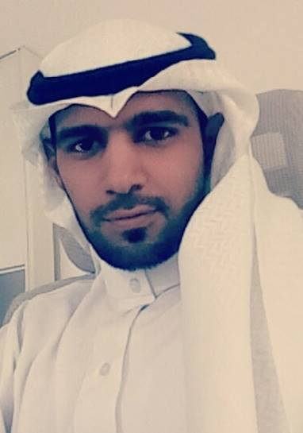
Jamil

Email: jamil.387533@2freemail.com

Objective:

To work with some big & well-known organization with challenging working environment which can give me good exposure and help me in putting my dedication, knowledge, skills and abilities for the career development as well as organizational development.

Career Summary:
- A dynamic and sincere professional with 10 years of rich experience in Insurance field.
- Excellent Insurance knowledge.
- Excellent knowledge of Insurance Accounts Payable & Receivable processes and procedures.
- Experience in using Oracle and other similar accounting systems.
- Proficient in team member, determined & quick learner with good interpersonal skill.
- Expert in analyzing the business proposals especially in Insurance terms.

WORK EXPERIENCE:

Insurance Coordinator / Insurance Supervisor.
Family Care Hospital, Riyadh, Saudi Arabia.
- Produced month end and end of year Insurance statements - Submissions, Payable and Rejection Reports.
- Managed Reconciliations and Rejections, generating Summaries and monthly statements.
- Handling Complaints of Insurance Companies.
- Handling the complaints from Insurance Patients.
- Communicating Insurance Companies to solve the Issues.
- Submission of the Monthly Claims on time.
- Keeping records of the Monthly Claims Submitted.
- Arranging Settlement Appointments.
- Coordination between Insurance reception & Insurance Patients in case of rejection.
- Revising & reviewing the Pricelists.
- Making new Contracts with Insurance Companies.
- Revising the old Contracts.
- Preparation of cover letters.
- Making updates in the Medical Provider Network.
- Handling technical aspects of rejection from Insurance Companies.
- Worked as medical approvals supervisor.
- Also worked as claims supervisor.
- Claims rejection Reviewer and Reconciler.
- Data analyst.
Assist Insurance Manager
Typical Medical Clinic, Riyadh, Saudi Arabia.

- Produced month end and end of year Insurance statements - Submissions, Payable and Rejection Reports.
- Managed Reconciliations and Rejections, generating Summaries and monthly statements.
- Handling Complaints of Insurance Companies.
- Handling the complaints from Insurance Patients.
- Communicating Insurance Companies to solve the Issues.
- Submission of the Monthly Claims on time.
- Keeping records of the Monthly Claims Submitted.
- Arranging Settlement Appointments.
- Coordination between Insurance reception & Insurance Patients in case of rejection.
- Revising & reviewing the Pricelists.
- Making new Contracts with Insurance Companies.
- Revising the old Contracts.
- Preparation of cover letters.
- Making updates in the Medical Provider Network.
- Handling technical aspects of rejection from Insurance Companies.
- Worked as medical approvals supervisor.
- Also worked as claims supervisor.
- Claims rejection Reviewer and Reconciler.
- Comparison of the pricelist between Clinic and Insurance Companies in order to reduce the rejections.
Medical Network Coordinator.
Saudi Arabian Cooperative Insurance Company (SAICO), Riyadh, Saudi Arabia.

- Addition & deletions of the members in the Insurance Policies.
- Printing of Insurance Cards.
- Filing Contracts of the providers.
- Processing of the Claims.
- Customer Service Representative.
- Contacting the Health Care Providers for the confirmations of the GAA’s (Group Admission Advises).
- Additions / Deletion of the providers in the Medical Policies.
- Preparing the GAA’s (Group Admission Advises).
- Reconciliation with the providers in order to close the yearly / Half yearly / Monthly account.
Network Administrator.
RS CAFE, Riyadh, Saudi Arabia.

- Hardware / Software Troubleshooting.
- Maintenance and troubleshooting of the Network and switches.
- Customer Service / Sales Representative.

EDUCATION LOMA (Basics Of Insurance)
Saudi Arabian Co-operative Insurance Company (SAICO), Riyadh, Saudi Arabia.

Bachelors in Computer Science (BCS) 2009
Star Gate Institute, Riyadh, Saudi Arabia.

HSC 2005
Pakistan International School Riyadh, Saudi Arabia

MATRICULATION 2003.
Pakistan International School Riyadh, Saudi Arabia.

INETERSTS
I enjoy travelling, learning about different cultures and sight-seeing, visiting cultural events, sports activities, getting to know and sharing interests with new people

