CURRICULUMVITAE
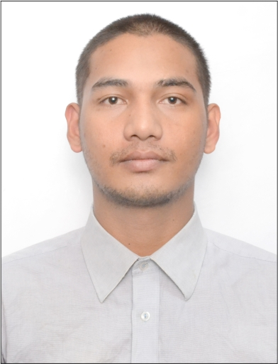

RAHUL

Email: rahul.387534@2freemail.com

OBJECTIVE:
I am keenly interested to working in the atmosphere of challenging, adherence and humanly nature which provide me a solid platform for a bright future in the challenging work, place an opportunity to me for better utilizations of
My knowledge and ability.

JOB DESCRIPTION:

CUSTOMER SERVICE / REPRESENTATIVE
- Ability to read customer.  - Ability to use positive language.  - Follow “listen and apologize solve the problem and thank you”  - Make sure about customer recovery.  - Ability to handle customers in peak hours and non-peak hours.  - Goal oriented focus.  - Ability to do Closing shift.  - Maintains all food with highly food safety standard | - Provide a reputable quality of food for fast food. Involving in planning and implementation of creative dishes in Kitchen.  - Ensures maintenance of establishing standards..  - Special in Burgers, Sandwiches, Salads  - Any other duties, which may be assigned to me from time to time as directed by our supervisor or manager

WORK EXPERIENCE:
Helper | - From 05th May 2015 to 24th November 2015 | - Barca Med launge

Crew Member |  | - From 29th  November 2015 to 25th January 2017 | - MacDonald’s India
Crew Trainer | - From 25th April 2017 to 24th September 2018. |  | - MacDonald’s India
EDUCATION:

- 10th Passed from Central Board of Secondary Education in Delhi (India) in 2012.
- 12th Passed from CBSE Board Delhi (India) in 2014.

PERSONAL INFORMATION:
Date of Birth : 17th December 1996
Language Known : English& Hindi
Marital Status : Unmarried
Nationality : Indian

