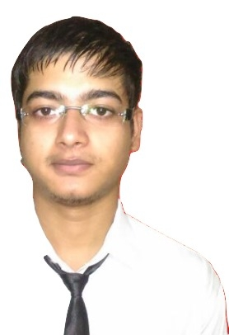 SURENDER
Email: surrender.387535@2freemail.com

PROFESSIONAL
SUMMARY Upbeat and flexible Cashier cum service who is highly energetic, outgoing and detail-oriented, Handle multiple responsibilities simultaneously while providing exceptional customer service. Driven and result-focused with expertise in multiple restaurant roles.

Customer service  Accurate money handling  Operation management  Issue resolution  Active listening skills  Pos software expert  Negotiation | Opening and closing procedure  Data entry  Inventory management  Credits and transactions  Basic administration knowledge  Vendor Management

SKILLS

WORK HISTORY Restaurant cashier cum Service. C&cfood (TheMunchBox)
New Delhi, India. June 2017 to December 2018
- Greet customers including answering phones and directing customers inquires to the appropriate party.
- Monitored cash intake and deposit records to increase accuracy and reduce discrepancies.
- Handled scheduling to insure proper for high-volume shift and seasonal promotions.
- Provided excellent customers service, driving membership loyalty and increasing customers’ satisfactions rates.
- Supported Store opening by setting up office space, equipment and POS Systems.
- Performed IT supported by troubleshooting, updating device and supporting software needs.
- Managed monthly inventory transitions by creating templates to ensure optimal food and beverage stock.

Restaurant cashier cum Service. TASA ASSOCIATES (BUN-INTENDED)
New Delhi, India. April 2016 to May 2017
- Inform customers about services available and assesses customers’ needs.
- Updated team members about changes in restaurant products services, pricing and polices.
- Greeted and welcomed all restaurant guests with smile.
- Improve customer’s service rating through zomato, swiggy & Foodpanda.
- Managed all day of cash in proper way.

Restaurant cashier. MAD ASSOSIATES (BAKING BAD)
New Delhi, India. October 2014 to March 2016
- Resolve escalated issue with angry customers.
- Enter details such as payments, account information and call logs into the computer system.
- Responded to customers request via telephone and email.
- Support head chef with daily operational functions.

CERTIFICATION Degree in Bachelor of computer application.
Diploma in Advanced Computer Application.

EDUCATION Bachelor of Computer Application. Maharshi Dayand University
Rohtak, HR India. 2014
12th Passed from Navyug School, Sarojini Nagar,
DL India. 2010
10th Passed from Navyug School, Sarojini Nagar,
DL India. 2008

PERSONAL RECORD

Marital Status: Single
DOB: 15-August-1992
Nationality: Indian
Languages Known: English & Hindi

