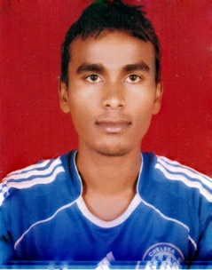

HARENDRA
Email: harendra.387585@2freemail.com

Career Objective:

To enhance a career that tests my professional abilities, add value and make an attempt to achieve organization and individual goals, also to further enhance my skills through learning and meet the challenges in any giving chance.

Work Experience:

- Excellent experience in carrefour department.
- Picking putway , distribution, goods receiving.
- Excellent knowledge in Receiving & distribution.
- Excellent knowledge in efreight suite system ,WMS.
- Know working in AMI middle EAST logistics Dubai Jebel Ali free zone on the post of tally Clark since 2016 to till date.
- warehouse assistant in mohebi Logistics Jebel Ali free zone Dubai UAE since 2013 to 2016.
- Good experience in warehouse works.
- Goods receive from RF and tablet.
- All Carrefour cargo handling.
Training

- Warehouse tally clerk.
- Excellent knowledge in WMS.
- Excellent knowledge in freight forwarding.
- Basic Office package (MS-Word, Excel, Power Point, Email, Internet) etc.
- Tally.
- WMS, EWMS( making GI,ASN making, truck consignment, delivery note , pick list making etc)

Strengths:

- Self motivation and a Passion to Succeed
- Hard working
- Good Communication Skill

Educational Qualification:

- intermediate from tribhuwan univercity Nepal 2066(B.S)2nd
- S.L.C from H.M.G School Nepal 2062(B.S) 2nd

Personal Details:

Date of Birth : 25.July.1990
Gender : Male
Nationality : Nepali
Marital Status : Single
Languages Known : English, Hindi and Nepali

