Curriculum vitae
Anand
Email: anand.387790@2freemail.com
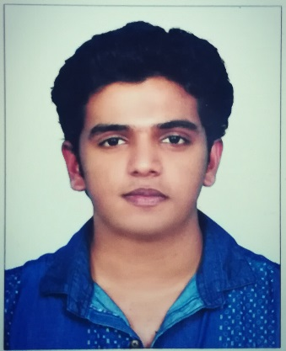
Career Profile/Cover letter.
- An energetic, enthusiastic, motivated and dynamic HSE-Officer, with certified “NEBOSH” IGC, 1, 2&3 passed in credit. A Graduate with comprehensive knowledge and understanding of General Health &Safety and Environment Management System,” RISK ASSESSMENT and CONTROL” and as well with general Security protocols and operations.
- Well qualified and result oriented individual with 2+years’ experience in Dubai, industry varying from, Administrative Support, Infrastructure Security and “A professional Health and Safety Officer”.
- Possesses a supportive and encouraging management style, with an innate ‘can do’ approach and outstanding Communicational skills.
- Possesses exceptionally strong people management skills combined with expert negotiation and influencing expertise and a finely tuned ability to build relationships on all levels, both with clients and staff members.
- Currently seeking career in your reputed organization in EHSS which would help me achieve my goals.

Career Skills
General Health & Safety Management System Risk Assessment & Control Measures

Infrastructure Security &Fire/Other Hazards Precaution Legal &Public Relations on EHS

Professional credential experience

- Currently working as an Assistant Safety Officer in Emirates Group security, TRANGUARD from 2017 May till the date in Jumeirah Golf Estates. DP World.

- Worked as a Team Leader in Emirates Group Security, TRANGUARD for a period of 6-Months 2016 December to 2017 May in Dubai Miracle Garden. DP World.

Personal Details

Name: Anand
Gender/Sex: Male

Nationality: INDIAN

Date of Birth: 31-01-1995

VISA Status: Dubai Employment Residence VISA (Free zone)

Notice Period: 15 Days or Less

Languages Know: English, Hindi, Malayalam, Tamil

Religion: Hindu

Marital status: Married

Professional Qualifications

- NEBOSH IGC

- COSHH safe use and handling of chemicals

- IOSH Managing Safely

- First Aid at Work

- Essentials of Fire Safety Principles

- NCFE- Level 3 Award in Health and safety for the work place.

- Dubai Protective Systems Certification from the Dubai Police Headquarters -Valid till Dec- 2019

Academic Qualification

Qualification | Accreditation | Year
- Graduated in B. Com Commerce with Tourism and Travel Management. | Kerala University | 2013-2016
- Intermediate in PCB and Mathematics | Higher Secondary Board NCERT- India | 2010-2012
- Matriculation | Government of Kerala | 2010

Duties and Responsibilities

- Responding to emergencies which need immediate attentions like fire, accidents etc.

- Conducting Tool Box Talks and give briefing to the team about the standards of operating procedures and safe working manners.

- Accompanying the EHSS officer in community risk assessments and hazards identification in work place prior to the constructions activities going on inside the communities.

- Preparation and reporting of events such as accidents, dangerous occurrences, and near misses that happening inside the community area and worksites.

- Accompanying the EHSS Officer in pump room inspections.

- Insuring smooth traffic and implementing traffic control instructions whenever needed.

- Insuring the Safety and Security of all kind of people in premises such as members of public, visitors, residence, contractors, maintenance people and the house keeping staffs.

- Accompanying Police, Emergency personnel, Civil defenses during patrol or in case of occurrences.

- Maintaining the access control and verifying the permit to work system to insure no unauthorized activities inside the premises.

- Security hotline operations and responding to quires and complaints.

Computer Skills

- Galileo, Computerized Reservation System (2015) (CRS)
- MS Office

Reference

Available

