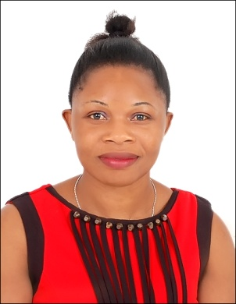

Name : Maxecia
Sex : Female
Date of birth : 15/ 08 / 1987
Nationality : Ugandan
Status : Single
Email address : maxecia.387829@2freemail.com

PERSONAL PROFILE
A hard – working, self driven and motivated with extensive experience, caring and disciplined. I have the natural ability and the appropriate skills to work in customer – focused organizations with great enthusiasm and dedication. I am patient, understanding and flexible on the hours and shifts.

CAREER OBJECTIVE

Willing to do a job in reputed area to apply my skills and hence experience.

ACHIEVEMENTS
- Awarded as employee of the year [2010] at Sarah beauty centre Kampala.
- Awarded as most improving staff transport section at New valley.

EMPLOYMENT EXPERIENCE
- Working as Hair dresser assistant at Sarah beauty centre 2009.
- Working at New valley as bus attendant 2014
- Join Estaqlal private school Dubai as bus conductor and a cleaner 2017.

EDUCATION BACKGROUND
- Primary leaver education at Winton boarding school in 1998.

OBJECTIVES
- Provided information, advice, guidance and assistance as required to patrons.
- Provided customers requirement on timely manner.
- Carried out various roles such as porters, commissioners and valet parking attendant.
- Provided the maximum level of service possible
- Developed a rapport with guests in order to understand their needs
- Created strong relationships with service suppliers
- Provided accurate and important information to consumers.

SKILLS
- Able to handle my job in a proffessional way.
- Good in English communication and moderate Arabic.
- Interpersonal and adapting skills
- Able to work under pressure
- Create strong relationship with service supplier as they provide services
- Expert in creating database of customer

REFEREES
Available

