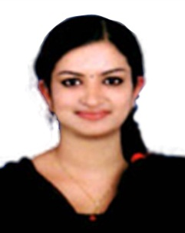
LIVIYA

Email: liviya.387835@2freemail.com

Career Objective

A dynamic and result oriented individual seeking a challenging position where former work experience can contribute to organizational goals and objectives, to learn something new and willing to accept challenges.

Experience & Job Responsibilities
Worked as an Assistant Sales coordinator in Anson Group of Companies, Kerala, India from June 2018 to Dec 2018 for a period of six months.

Anson Group is a financial company having Head Office in Kerala, India with 19 Branch Offices in South India.

Experience as an Assistant Sales coordinator in Anson Group of Companies.

- Sales & Marketing of investments and deposits
- Team handling for achieving monthly targets assigned.
- Encouraging and informing the client’s offers and schemes for better value of money.
- Building and maintaining the relationship with the customers.
- Build customers interest in the services and products offered by the company.
- Active participation in accounts related works such as maintenance of cheque book log, handling of return cheques as well as postdated cheques.
- Keeping track of deposit and inform clients the maturity of various deposit

Abilities and Key Strengths
- Ability to work efficiently & effectively in any working environment to complete the assigned task on time.
- Experience in office management with comprehensive problem solving abilities.
- Positive attitude
- Learning skill
- Computer Skills Operating System Windows 7,MS Office 2013,Word,Excell and Power Point.

Educational Qualifications

Sl.no | Academic qualifications | Name of institution | Board/University
1.  2.  3.  4. | M.com finance  B.com with Computer Application  Higher secondary commerce with computer application  SSLC | MES college Nedumkandam  College of applied science Nedumkandam  Holy cross senior secondary school  Holy cross senior secondary school | Mahathma Gandhi university  Mahathma Gandhi university  CBSE  CBSE

Linguistic Abilities
To Speak : English, Malayalam and Tamil
To Read & Write : English, Hindi, Malayalam and Tamil
Personal Details

Nationality: Indian
Date of Birth: 01/12/1994
Marital Status: Single

