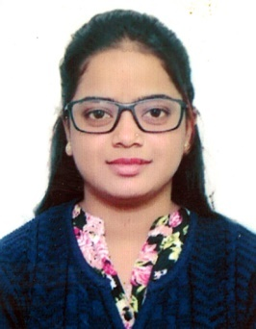

SOUNDARYA

Email : saundarya.387840@2freemail.com

OBJECTIVE:To be accompanying with a forceful organization in the challenging position wherein my education and experience will be developed and be followed for continuous growth and development.

SKILLS:
- Time Management
- Self-Motivation
- Adaptability
- Teamwork

WORK EXPERIENCES:

Red Nail Saloon and Spa (April 2018–present) as Beautician.

EDUCATIONAL BACKGROUND:

SSLC. SECONDARY HIGH SCHOOL

PERSONAL DETAILS:

AGE: 20
BIRTHDAY: DECEMBER 19, 1999
NATIONALITY: INDIA
RELIGION: HINDU
STATUS: SINGLE and in GOOD HEALTH
HEIGHT: 5’0
WEIGHT: 42

