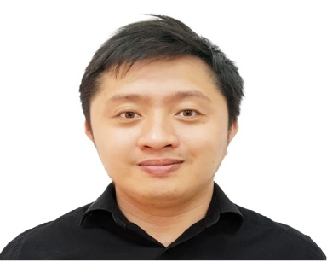
Andrie
E-mail: andrie.387838@2freemail.com

- CAREER OBJECTIVE
To secure a position as a Quantity Surveyor in an organization that offers professional growth utilizing academic & mental potential to the fullest extent possible.

- CAREER SUMMARY
A self-motivated and results driven individual, with 3 years of experience as a Quantity Surveyor in Dubai, that possess a reputation for attention to detail, integrity, an ability to adopt to different cultures and processes with a strong work ethic.

- CORE QUALIFICATIONS
- Bachelor of Science in Civil Engineering – Philippines

- PROFESSIONAL QUALIFICATIONS
- Registered Civil Engineer – Philippines
- Member of Philippine Institute of Civil Engineers, U.A.E Chapter

- STRENGTHS
- Possess a creative, outgoing, and exceptionally positive personality.
- Remarkable ability to effectively implement and accomplish assigned tasks in a timely manner without sacrificing quality.
- Excellent ability to effectively juggle several priorities in a fast-paced setting.
- Extensive knowledge and experience in the field, with a proven ability to suggest improvements and produce perfection in negotiations and recommendations.
- Highly organized and attentive to even the minutest details.
- Superior analytical and problem-solving skills
- Proficient in using applications like Planswift, Microsft Office, and Autocad.
- WORKING EXPERIENCES
Employer : Gulf Technical Construction Company, Dubai UAE
Position : Quantity Surveyor
Duration : January 2016 to January 29,2019

Involvement : Pre-contract
- Reviewed tender documents and ensure that all data required for pricing are available
- Prepared technical queries such as, details, missing documents pertaining to tender
- Prepared a quantity take-off from the drawings according to the project BOQ
- Carried out any other relevant duties as required or as detailed from time to time by the superior.

Involvement : Post-contract
Project : The Pointe, Palm Jumeirah
The Pointe is a Palm Jumeirah development located at the tip of the Palm just across
the bay from the Atlantis Hotel. It is a large scale complex that include retail shops,
F&B outlets, Mono Rail Station and Promenade
- Placed orders with subcontractors and managed subcontractor’s claims and resolved disputes.
- Prepared payment certificates for subcontractors and send out notices to subcontractor to proceed work as established.
- Verified any technical changes required in variation orders prepared during the implementation of the projects, by preparing a special report attached with the variation orders.
- Prepared monthly cost reports for subcontractors.
- Check the quantities in BOQ during site hand over and match them with the implemented quantities at the site.
- Attended site meetings with subcontractors and engineers.
- Carried out any other relevant duties as required or as detailed from time to time by the superior.

- LOCAL EXPERIENCES
Employer : First Oceanic Property Management - Philippines
Position : Property Engineer
Duration : 2012 to 2014
Involvement : Handled all the technical aspects needed in the assigned property.

- PERSONAL DETAILS
Full Name : Andrie Siazon Burog
Date of Birth : April 2
Nationality : Filipino
Gender : Male
Marital Status : Single
Language Proficiency: English and Filipino

