KISHORERAJ
Email: kishoreraj.387844@2freemail.com
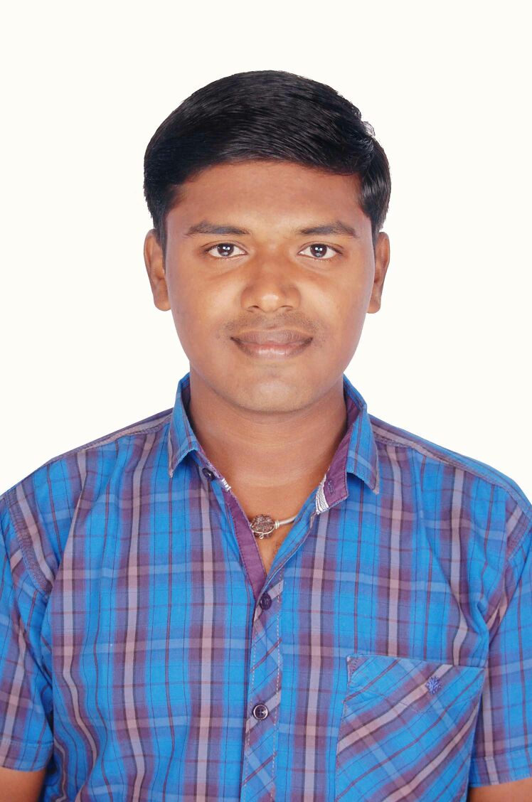
CAREER OBJECTIVE
To obtain a responsible and rewarding position in a professionally managed organization that will steer my career forward. I am looking for an opportunity where I can utilize my skills in contributing effectively to the growth of the organization which will in turn improve my personal skills and knowledge.
EDUCATION
- Bachelor of Engineering. (Mechanical)(7.45cgpa)- 2018.

CORE STRENGTHS
- Quick learner, Positive Attitude
- Good communication and interpersonal skills.
- Meticulous and hard working.
- Setting up higher standards of performance.
- Ability to manage challenges.
- Adaptable to any changing environment.

CERTIFICATION
FANUC Certified Production and Quality Engineer
AWARDS AND ACHIEVEMENTS
- Got Rajyapuraskar award in THE BHARAT SCOUTS & GUIDES by state governor of Tamilnadu, India.
- Second prize in National level workshop in Ardubotics Robotics at M.R.K Institute of technology, Kattumannarkoil, Tn, India.
- Certificate of Participation in workshop on IC ENGINES & AUTOMOTIVE SYSTEMS held at M.R.K Institute of technology, Kattumannarkoil, TN, India.
SKILLS AND FAMILIER AREAS
- Knowledge for Machining, fabrication, Grinding & various process involved in production activities.
- Production Planning & Control (PPC).
- Supervision of daily production activity
- Familiar to measuring instruments Vernier Caliper, Micro Meter
- Welding processes and theory (Arc, Tig)
- Quality and Inspection
- Manufacturing&Production
- Mechanical oriented works

TECHNICAL SKILLS
- Auto CAD Basics
- Microsoft Office Word, Excel & Power Point
PROJECT DETAILS
Main project on “REDUCTION OF NOX FROM SINGLE CYCLINDER DIESEL ENGINE BY INJECTING AMMONIA”
- The main objective of this project is to remove the exhaust toxic gases mostly of Nox from the single cylinder diesel engine
- By using the mango seed oil as a bio diesel and also injecting the ammonia on the tail pipe.
Mini project on “DESIGN AND FABRICATION OF SHAFT DRIVEN BICYCLE”
- The main objectives of this project is the bicycle is driven by a bevel gear and shaft setup
- Instead of chain setup, This will increases the cycle speed and should be useful for racing purpose.

PROFESSIONAL EXPERIENCE
EMPLOYER: CRP INDIA PRIVATE Ltd, India Jun-2018 to Dec-2018
POSITION: TRAINEE at Machine Department
- Responsible for operate the machine according to its cycle of operations
- Responsible for operation, maintenance, installation and repair of the equipment.
- Responsible for providing feedback to senior design engineers on customer problems and requirements.
- Check and update daily completed job details and also to check all the gauges
- Verify the product dimensions, weight etc.,
- Inform to line supervisor if any machine defective and correct it.
- Also check and replace the tools life
- Responsible for checking the lubrications to machine, to ensure the coolant etc.,
PERSONAL DETAILS
Nationality : Indian
Date of Birth : 10.08.1995
Marital Status : Single

