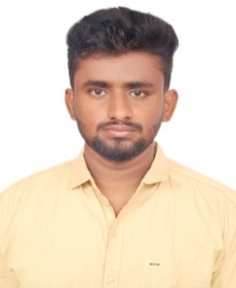 | MELWIN  MECHANICAL ENGINEER
Email:  melwin.387855@2freemail.com  PERSONAL DETAILS  Date of Birth : 10/03/1997  Languages Known : English,Tamil  Nationality : Indian | objective
 | To grab a position that allows me to improve my skills as well as organization position. Looking forward to take responsibility and to serve to show my skills.
 | EDUCATION
(2014-2018) B.E. MECHANICAL ENGINEERING
K.S.Rangasamy college of technology - 75.8%

(2012-2014) HSC
St.Mary’s Higher Secondary School - 75.4%

(2011-2012) SSLC
St.Mary’s Higher Secondary School - 87%

 | personal skills
- Ability to understand and present others point ofview.
- Thinking both creatively and logically to resolve design and developmentproblems.
- Creative innovative with good designskills.
- Willing to learn and flexible in any source of designmatters.
 | experience
MICRO PRECISION(June 2018 – November 2018)
Working as a Graduate Engineer Trainee
Responsibilities for Quality checking
Duties
- Process overhead
- Checking project at every stage
- Quality checking

SOFTWARE PROFICIENCY  - AutoCAD 2D&3D  - CATIA  - PTC Creo 2D&3D  - Pro-E  - ANSYS  - Adobe Photoshop  - Adobe Premiere  - Adobe After Effects  - Microsoft Packages | IN-PLANT TRAINING UNTERTAKEN
 | - Attended In-plant training about crane manufacturing for 3 days at Mega Cranes India Private Limited, Coimbatore.
 | INDUSTRIAL EXPOSURE
- Undergone Industrial Visit at Tea Factory, Ooty.
- Undergone Industrial Visit at Malabar Cements, Kerala.
 | ACADEMIC PROJECT
 | - Project on Design and static analysis of trolley with multi degree rotation.
 | CO-CURRICULAR ACTIVITIES
- Secretary in Sparks Association of mechanical department and well in leadership quality.
- Completed a many module in IIT Madras through the QEEE Program.
- Attended National level Workshop at Sri Krishna College of Engineering & Technology, Coimbatore about Current Trends in Automobiles.
- Presented a paper about Air Brake System in Mechgust’16 at Chennai Institute of Technology, Chennai.

