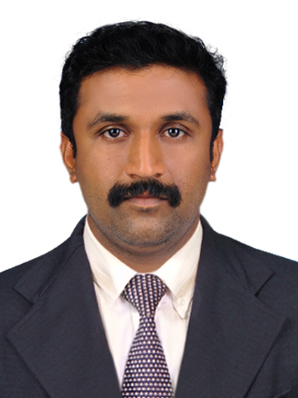
ADUL

Email: adul.387915@2freemail.com

EXPERIENCE SUMMARY
Accomplished Graduated Electrical Engineer specialized in power sector and construction field with 4 years’ experience in the field of Automation, testing operation and maintenance of substation and control room. Experienced in industrial and commercial Electrical works, Seeking Engineer level assignments across Industries
TECHNICAL EXPERTISE
- Substation operation and maintenance.
- Strong knowledge of control room operation procedures and regulations
- Commercial, Industrial & Residential Building related Electrical Works
- Electrical maintenance.
- Substation construction site execution and management.
- Testing and installation of relays and control/protection scheme & panels
- Technical & contractual document preparation and review.
- Co-ordination - client, consultant, subcontractor, vendor.
- Control wiring.
- Regulation of power between transmission stations and distribution sections
- Testing and calibration of Energy meters
- Basic knowledge in FIRE ALARM SYSTEMS
- Automation using PLC AND SCADA
TECHNICAL QUALIFICATION
- Certified Automation Engineer in PLC (Programmable logic control )
- Allen Bradley
- Siemens
- Shneider
- SCADA (Supervisory Control And Data Acquisition.)
- Wonder ware In touch(version 10)
- Microsoft Office Word, Power Point and Excel
WORK EXPERIENCE

- Worked at BUILTECH BUILDERS AND CONSULTANCY as engineering trainee and FACILITY MANAGEMENT SUPERVISOR for 14months.Managing the work,Facilities to ensure needs of Organisation and its Employes,Planning day to day operations in maintenance and services,Security measurements in work sites.
- Completed 3months Electrical Engineering Apprenticeship from RUBCO HUAT WOOD (P)ltd.in Maintanance and Installation of Induction motor and Generators and scheduled maintenance inside the indusrial compound.
- Worked as SERVICE MANAGER & SERVICE ENGINEER in SAMSUNG SERVICE CENTER for 6months.co-ordinating service technicians and employes in recognizing and completing service issues and reapirs of home appliances.
- Worked as Shift Assistant along with Apprenticeship training for 1year in KSEB 110KV SUBSTATION Thalassery. Examined installations and observed operations to ensure conformance to design and equipment specifications, and provided technical assistance to field personnel in the areas of high voltage distribution equipment and high voltage motors/. Carrying out operation, control of 110/11KV substation, Routine and breakdown maintenance of 12.5MVA,10MVA power transformers,20MVAR capacitor bank,200AH Battery bank, PT,LA, CB, CT, NCT Transformer oil filteration plant (HOC PLANT)etc.
- Worked as Operations and Maintenance Engineer for 1year in KSEB 110KV SUBSTATION panoor Operations and maintenance of substation equipment’s 10MVA,16MVA power transformers etc. control wiring cable laying, Protective Relays, Trouble shooting of system failures and rectification. Supervised a team of two electricians responsible for cable pulling, tray installation, high level wiring of lights, small power and lighting, making off circuits in distribution boards responded and provided technical assistance to electrical equipment problems within the company-owned facilities.
  - Involved in Bay Extension work for 110kv substation panoor. Supervising earth mat, control cable laying and termination works, taking measurement and prepare bill for assisting higher officials, Prepare estimate for different construction and maintenance works, Worked in testing and installation of static and mechanical relays of various make such as ABB, SIEMENS, AREVA, BROWN BOVERI, SEL, ALIND and ALSTOM,Inolved in Testing and commissioning of power equipment’s.

ACADEMIC CREDENTIALS

- Completed B.Tech (Electrical and Electronics Engineering) from College of Engineering, Thalassery Affiliated to CUSAT University, kochi, Kerala, India. With 58.60% mark in 2014.
- +2 with Science from Board of Higher Secondary Examination, Kerala with 81% mark in 2010.
- SSLC from Board of Public Exams, Kerala with 85.0% mark in 2008.
ACADEMIC PRESENTATION

MAJOR PROJECT ON TOPIC AUTOMATION OF BALL MILL ROCKFEEDING SYSTEM IN PHOSPHORIC ACID PLANT USING AC DRIVES Done at The Fertilisers And Chemicals Travancore Ltd
INTERPERSONAL SKILL

- Possess excellent inter personal, communication and analytical skills,good administrative and problem solving capability,intrinsic abilities to shoulder responsibilities at the highest level of competence,and have good analyzing & understanding capability for corrective decision-making

PERSONAL DETAILS

Nationality: Indian
Date of Birth: 16thFeb 1992
Marital Status: Single

