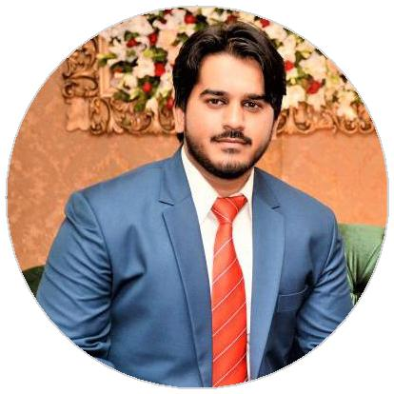
Usman

Network Engineer

Looking forward to an opportunity for working in a dynamic, challenging environment, where I can utilize my skills for developing my career and for the growth of the organization as a Network Engineer to eﬀectively implement the installation, configuration and maintenance of IT network.

WORK EXPERIENCE

IT Support Engineer
Can IT Support & Services

08/2016 – 11/2018

Tasks
Supervised many projects of Network infrastructure design and implementation.

Solve multiple issue of Networks in Sialkot in recent times.

- Deployed Cisco switches, configured biometric machines and Microtik Firewalls in many organizations. Installed and configured IP cameras.

Contact: Hafiz Sajjad Rafique – info@canitnetworks.com

Network Adminstrator
Miqraz Surgical Industry

12/2017 – 05/2018

Tasks
Cloud base data storage configuration. Administration of Domain Controller 2012 Server

Troubleshooting the Network and client end problems.

Keeping IT Dept. Up to Date.

- Configuration of biometric attender machine and IP cameras

Contact: Muhammad Irfan – info@miqraz.com

Network Administrator Govt. Murray College, Sialkot

05/2017 – 11/2017

Tasks
Implementation of Cisco Switches in Lab to expand their networks.

Configure a VPN Connection with University Of Gujarat

Contact: Prof. Touseef Akhtar – principal.murray.skt@gmail.com

EDUCATION

BS (Hons) Information Technology University of Gujrat

05/2017

Intermediate in Science Punjab Group of College, Sialkot

03/2013

Metric in General Science
City Public High School

EXPERTISES

Cisco Routers / Switches Microsoft OS / Server

Cloud Storage Troubleshooting

Routing Protocols IP & CCTV Cameras

Firewall LAN/WAN Bio-metric Machines

PROJECTS & ACHIEVEMENTS

The PRAK's Hotel

Wireless Configuration, Microtik firewall, Cisco POE switches and Network Cameras.

Al-Farooq Noori Public School

Network Design and Implementation

Allied School

Map Drive & IP Printer Configuration

Spry Sport Corp.

Configured Server 2012 and Microtik Firewall.

Marvel Wear Industry

Network Configuration and Troubleshooting

CERTIFICATES

Cisco Certified Network Associate (200-125)

Certification Number : 434172287191DLBL

Microsoft Certified Solutions Associate (Server 2016)

Certification Number : G931-1718

Microsoft Certified Solutions Expert (Server 2012)

Certification Number : G744-0734

LANGUAGES

English

Urdu,Hindi

INTEREST

Cricket Snooker Travel Novel Reading

03/2011

