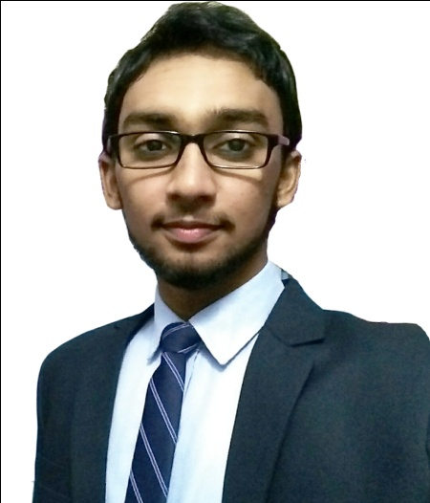

*Tech-friendly – Experienced in MIS*

*Conceptual and Analytical skills*

*Effective Problem Solving and Leadership Skills*

*Good Interpersonal Skills*

* **Communicative**
* **Punctuality**
* **Creativity**
* **Organized**

**PERSONALITY**

**SKILLS**

*Interested in:*

*-Business Analytics*

*-Subjects like Organizational behavior, Social Psychology, Human*

*Resource Management.*

*Attended symposiums on:*

*-HR 2020, Changing workforce dimensions – NHRD Bangalore Chapter*

*-Personality Development*

*-Work Life and Job Satisfaction*

*-Psychological Skills Development*

**ACADEMIC INTERESTS**

*2016*

***Master of Business Administration – Human Resource***

*AIMS Institutes*

*Bangalore University*

*2013 - 2016*

***B.Sc Psychology - Percentage 85%***

*Calicut University*

*2011 - 2013*

***Computer Science (HSE) - Percentage 78%***

*Kerala**Higher**Secondary**Examination**Board*

*2010**- 2011*

***Secondary School Examination - Percentage 90%***

*Central**Board**of**Secondary**Education*

*ACHIEVEMENTS*

**IF YOU WANT TO REMOVE THE WATERMARK FROM YOUR CV**

**PURCHASE A PACKAGE AND UNLOCK EVEN MORE FEATURES.**

**THERE ARE 4 TEMPLATES YOU CAN USE FOR FREE: CLASSIC, ORB, MACHETE AND SAND.**

**YOU CAN USE ALL TEMPLATES JUST FOR $5.57 WITH UNLIMITED DOWNLOADS FOR 7 DAYS!**

**MORE INFORMATION: HTTP://CRAFT-CV.COM/PRICES**

**FREE PREVIEW**

**EDUCATION**

*To work for a well-reputed organization and to learn and acquire key skills and knowledge, utilize opportunities effectively for professional growth and to contribute in the best possible way for the betterment of the organization and self*.

**MS** **Office**

**Adobe** **Creative** **Suite**

**IBM** **Cognos** **Insight**

**IBM Watson**

**English**

**Malayalam**

**Tamil**

**Hindi**

**Arabic**

**SOFTWARE SKILLS**

**LANGUAGES**

Email: [hashir.388007@2freemail.com](mailto:hashir.388007@2freemail.com)

**OBJECTIVE**

**HASHIR**

**HOBBIES**

Available

**HESTIA** **MEDICARE** **HOSPITAL**, **COCHIN**

**(ERAM Group)**

**Project Title: A study on work life balance of women: at Hestia Medicare Hospital**

* **Recruitment**
* **Scrutinizing the suitable CV keeping in mind different criteria**
* **Conducting interviews**
* **Induction and On-Boarding**
* **Issuing appointment letter with brief working agreement or policies**
* **Giving a description on the policies and culture of the organization**
* **Employee Motivation and L&D**
* **Conducting training sessions**
* **Compensation and Benefits**
* **Helping for the registration of ESI**
* **Pay slip**
* **Performance management**
* **Employee engagement**
* **Exit formalities**

**ADITYA BIRLA FASHION & RETAIL LTD (ABFRL) BANGALORE**

**Project Title: A Study on employee attrition rate analysis and retention processes at Aditya Birla Fashion & Retail Ltd with special reference to new employees**

* **Recruitment**
* **Assisted South regional HR**
* **Training & Development**
* **Pragati 2.0**
* **Employee Survey Data Analysis**
* **Competitor Mapping**
* *IBM Business Analytics Course*
* *Post Graduate Programme in International Business (PGPIB)*
* *Pursuing an Online Course on Global Human Capital Trends from Columbia University – Canvas*
* *Advanced Excel certificate*
* *Digital Marketing certificate*
* *Social Media Marketing certificate*
* *MS Office Course Certificate*
* *Graphic Designing Course Certificate*

**INTERNSHIP**

**CURRICULAR ACTIVITIES**

**COURSES AND CERTIFICATIONS**

* *Shoe Polish Assignment*
* *Fair Deal - One Day Business*
* *Started College HR Club*
* *Presented Case Study on Colgate Palmolive*
* *Food Festival*
* *Selected as Best Actor in college and district level Arts Festivals*
* *Elected as Fine Arts Secretary in college union*
* *Best National Service Scheme (NSS) volunteer*
* *Best Outgoing Student*
* *Conducted medical camps under an NGO*
* *Selected as President of students organization and*

*conducted various programmes*

**ACHIEVEMENTS**

**REFERENCE**

  

Acting in plays Playing Football Watching Movies