Fawad 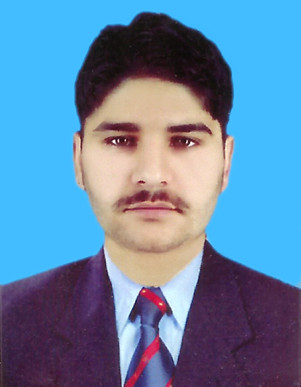
Date of Birth  18-June-1995  Nationality  Pakistani  Religion  Islam | Email: fawad.388048@2freemai.com  Objective:
 | Seeking opportunities in a challenging environment and grow as a proficient, innovative, committed and to contribute my professional skills as a team player to an esteemed organization with an ever learning and dynamic aptitude serving for organization’s as well as self prestige.
 | Education:
- DAE (Civil June 2011 ~ June 2014)
(Board of Technical Education Peshawar)
- Matric (Science 2011)
(BISE Peshawar)
♤ BA (politicial science 2017)
♡ B.tech ( 7th semester)
♡ Typink speed (50 wpm)

Professional Computer Courses:

- 3 Months Certificate in AutoCAD ((Building & Road)
From AutoDesk ER Solution Under the supervision of CMS Chamber of CAD Peshawar Pakistan.

- 1 Month Certificate in Microsoft Excel (Computerize Quantity )
From CMS Chamber of CAD Peshawar Pakistan.

Experience:
- 7 Months worked as trainee Quantity Surveyor (03 July 2014 ~ 30 May 2015)
With CMS (Construction & Management Service) Peshawar

- Building Estimation
- Bar banding Schedule
- Make BOQ in Microsoft Excel
- Road Estimation
- Works on Survey Data & Prepare in Microsoft Excel
- Make Cross sections in AutoCAD

 | Language Proficiency:
 | English, Urdu, Pashto
 | Strengths:
 | Hardworking, professionally committed, ability to take initiative, adaptable to hectic working conditions, willing to re-locate and team worker.
 | .

