CURRICULUM VITAE
OFFICE DRIVER
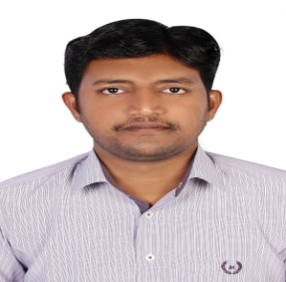

Rias

Email: rias.388056@2freemail.com

Career objective

Seeking a position in a reputed organization where I can provide safe and reliable transportation services and assist in the public relation activities.

Work Experience

KYE International General Trading L.L.C (2011 to Present)
Designation: Messenger & Driver
Network Cleaning & Security Services, Dubai, U.A.E (2008 to 2011)
Designation: Supervisor

Skills

- Dedicated and dependable driver with excellent track record of working for the senior professionals.
- Well knowledge about all U.A.E locations Road network.
- Collecting BL from shipping line office for export shipments.
- Experienced in Bank Transaction like Cheque and Cash Deposits and Withdrawals.
- Good communication & Interpersonal skills.
- Experienced in the delivery of technical submissions and payments with the Authorities like RTA, DEWA etc.
- Quick learner, Self motivated and confident individual.
- Receiving Guests and VIPs.
- Punctual at work and flexible to work long shifts.

Educational Qualification

Bachelor of Business Administration from the Annai College of Arts and Science affiliated to Bharathidasan University Trichy from the Period May 2005.

Computer Skills

- Operating Systems : Windows XP, Windows 7, Windows 10
- Office tools : Microsoft Office , Outlook , Internet & E-mails

Personal Data

Name : RIAS
Date of birth : 16.06.1984
Gender : Male
Marital status : Married
Nationality : Indian
Proficiency in Languages : English, Hindi, Tamil, Malayalam

License Details

Country : U.A.E
Class of Vehicle : Light Motor Vehicle (Auto)
Date of Issue : 28-07-2016
Date of Expiry : 28-07-2026

