Joven

Email: joven.388069@2freemail.com

Sex: Male

Nationality: Filipino

Civil Status: Single

Language: English, Tagalog & Basic Mandarin.

Curriculum Vitae
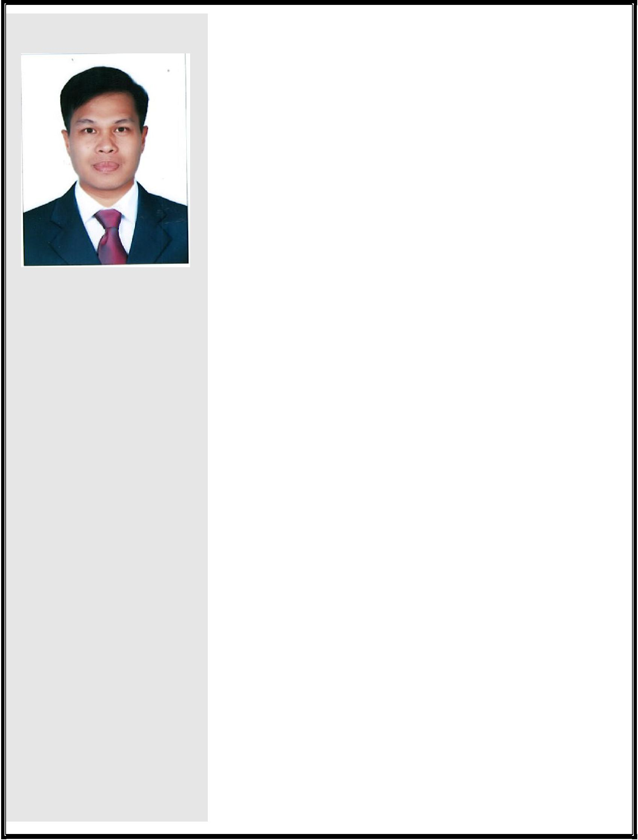

Career Objectives:

To work in an organization which provides the best opportunity for career and individual growth, where my skills and potentials are developed.

To adapt quickly to new and varied roles and to perform the highest standards in an under pressure working environments.

Highlights of Qualification:

Handles Full set of Accounting up to Finalization & Administration jobs for more than 12 years @ Strontium in 3 different Subsidiaries.

With knowledge in Microsoft Office, Tally and ERP Navision. Handles yearly Audit for 12 years.

Experienced in Purchasing for 6 years as part of Job in Singapore. Worked in Taiwan for 5 years as Production Line leader.
With good interpersonal English and basic mandarin communication skills.
Vibrant, Talented, Reliable and easy to work in as part of a team. Able to organize material information in more professional and

productive way.

Long Service awardee at Strontium Technology with 10 years of service.

WORK EXPERIENCES:

Senior Accountant
Strontium Assemblies Pte Ltd (Manufacturing Company)
178 Paya Lebar Road Singapore
May 31, 2018 to December 31, 2018

Responsible for the Full set of Accounting which involves posting journal entries into accounting system Navision.
Responsible for the Accounts Receivables, Accounts Payables of the company.
Responsible for GST filing quarterly.

Monitors and controls all cheque signatories, payment voucher and cash payment
Responsible for the preparation of documents for AMAZON Sales online.

Maintain office efficiency by ordering supplies for office and materials to be used in production.

Senior Accountant
Strontium Technology LLC (Trading Company)
Dubai U.A.E.

May 2014 to May 30, 2018

Over All In charge of Strontium Dubai Branch operations.

Responsible for the Full set of Accounting which involves posting journal entries up to Finalization in Accounting System, Navision.
Responsible for the Accounts Receivables, Accounts Payables of the company.

Responsible for VAT filing monthly.

Monitoring Cash inflows and outflows of the company.

Record and analyze the company's financial information. Review and monitor costs inherent in the business.

Accountant - General
Strontium Assemblies Pte Ltd (Manufacturing Company)
178 Paya Lebar Road Singapore
April 2008 – May 2014

Responsible for the Full set of Accounting which involves posting journal entries up to Finalization in Accounting System, Navision.

Responsible in Preparation of Financial Statements of the company for use in Annual Audit.

Computation of Bill of Materials for each product yearly. Responsible for GST filing quarterly.

Liaises with the Auditors in yearly audit.

Monitors and controls all cheque signatories, payment voucher and cash payment
Responsible for the computation of monthly payroll for the company with 32 employees and

Maintain office efficiency by ordering supplies and being prepared for rush job.

Responsible for the Import purchases of the company, scheduling of imports, Purchasing and delivery of goods.
Responsible in liaising with new suppliers for new product packaging. Office Administrator

Company’s administrator thus responsible in applying and renewing Work Passes for all employees and all other Administrative Jobs.

Accountant - General

Strontium Middle East FZE (Trading Company)
Jebel Ali Free Zone Dubai U.A.E.
January 2006 – April 2008

Responsible for the General Accounting which involves posting journal entries up to Finalization in Accounting System, Navision.
Responsible in Preparation of Financial Statements of the company for use in Annual Audit.

Responsible for Receivables, follow-up cheque payments from customers before the Due date of Invoice/s.
Responsible for the Payables of the Company, ensure that the payables of the company are paid before the Due date.

Responsible for the Bank Reconciliations Monthly.

Prepare Company’s payroll and Transfer of funds if needed. Monitoring Cash inflows and outflows of the company.

Office Administrator

Takes responsibility for all administrative concerns – liaises with respective JAFZA, Customs Documentation, Courier Service and Insurance personnel, to ensure that all requirements are met

Educational Background:

Bachelor of Science in Accountancy

Philippine School of Business Administration -Manila
October 1997 Graduate

Personal Qualities :

Computer literate (MS Office and Accounting System, ERP Navision & Tally.)

With Good communication skills (Verbal & written.)

Accurate, dependable and dedicated to doing best possible jobs. Team Player and can work well with others.

Can work with minimum supervision. Quick learner, Honest and hardworking.

