Email; harshita.388073@2freemail.com
Executive Assistant / Office Manager
aJune 2018 Harmony Real Estate Broker LLC

Till Date Office Manager
- Performing accounting tasks such as: processing payment, preparing invoice, payment voucher, receipt, cheque, etc.
- Maintain Proper filing of accounts documents for records & maintenance of customer data base.
- Liaising with the General Manager & developer once the deal is closed & confirmed.
- Manage all Marketing campaigns & Social Media of the company

Dec 2015 Air India SATS Airport Services Private Limited (AISATS)

Sep 2017 Executive Assistant

Office Management
- Taking dictations and transcribing into correspondence i.e. Letters, memoranda, official noting and reports for senior managers.
- Collection and preparation of MIS report along with collation of data for various departments.
- Take follow ups of the points discussed during the meeting for the timely closure.
- Verifying and cross-checking bulk of documents before SVP’s assent
- Preparation of PowerPoint presentations for Board Meeting, Group Meetings.
- Meeting and greeting visitors at all levels of seniority.
- Providing general administrative support to other senior executives.
- Sending a comprehensive report to the SVP of Monthly MIS of all departments of the point’s interest to the SVP.

Management Information System

- Monthly Performance Report
- Any other report of interest to SVP

Travel Management

- Responsible for managing Travel (Domestic and International)

Expense, claim & reimbursement Management

- Preparing expense settlement for SVP
- Preparing & approving expense authorizations, approvals. Ensure timely claims and reimbursements of the SVP.

Meetings Management

- Coordinating internal and external meetings, Audit Committee Meeting, Group Meetings, Monthly meetings, Weekly reviews, Project Partner review etc.
- Venue/Conference room blocking
- Circulation of the Minutes and Follow up for the timely closure of the agenda points.

Harshita
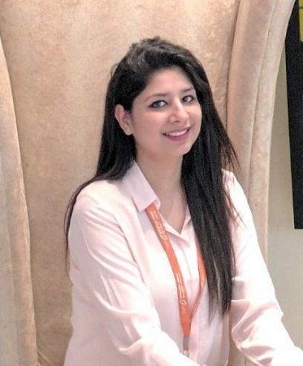
Based in Dubai and having a working experience of 3 years , I am very eager to work for an organization to grow and make every effort for the betterment of the company I am working for; Learning attitude, knowledge of UAE market & environment, and passion to work to grow are the key points for the goal achievement for me.

Education
Graduation – BSC(IT)- KU, Software eng.- NIIT, B.COM – DU

Achievements

- I have won several prizes at school level in the field of sports.
- Won the first prize in women doubles badminton in my organization

Skills
- Multi-tasking
- MS office proficient
- Communication Skills
- Dealing with Clients
- Organized
- Target-Oriented
- Certified JAVA, Oracle, Mysql

About Myself
- DOB – 30 December 1993
- Nationality – Indian
- Languages – English & Hindi

Calendar Management
- Managing and maintain the executives' schedules and appointments.

HR Roles and responsibilities
- Taking interviews
- Panelist of Sexual Harassment

Records Management

- Manage personnel files of external and internal documents from government
- Handle documents that has to be on the front / put up on the desired date & day by the SVP
- Record keeping for the daily incoming/ outgoing documents. Manage minutes of the Board Meetings.

Diary Management

- Provide support to the Senior Vice President on maintaining and managing key projects meetings and the meeting location.
- Send Daily Reminders to the SVP for timely reporting in the meetings.
Guest Management
- Arrange airport pick up/drop off, accommodation.
- Organize business Lunch or Dinner.

