RESUME
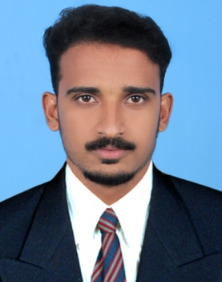

BALU
Email: balu.388092@2freemail.com

CAREER OBJECTIVE

A dynamic and ambitious aspirant seeking a career opportunity in an organization where I can utilize my key skills and capabilities for its growth. A highly motivated and self-directed Person, with a diverse educational background, focused on improving the financial status of the organization.

SKILLS AND KNOWLEDGE

- MS Excel, MS Word and MS PowerPoint.
- Auto cad 2015.
- Internet Applications.
- Quantity Surveying.
- Land Surveying.
- Fire Fighting Works.

EXPERIENCE

2016 to Now Site Supervisor (Civil) (contract Vise at ISRO )

EDUCATION

2016 : Diploma In Civil Engineering
Gurudev Technical Training Collage,Kilimanoor,Kerala
Marks- First Class

2011 :Higher Secondary (Plus Two)
Board of Higher secondary Education, Kerala
Marks (%) – 82%

2009 Secondary School (SSLC)
Board of Public Examinations, Kerala
Marks (%) – 95%

PERSONAL PROFILE

Date of Birth : 15 April 1993
Marital Status : Single
Nationality : Indian
Linguistic Abilities : English, Malayalam, Tamil,Hindi

