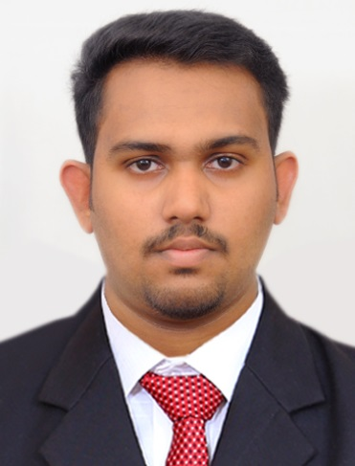

Accountant with 3 Years of Professional Experience

ANTU

Email: antu.388105@2freemail.com
“I am looking forward to join a vibrant and exciting organization where I can utilize my skills and keep good performance”
PERSONAL SKILL

  - Time management
  - Good in problem solving
  - Decision Making
  - Self-Confidence
  - Taking initiative
  - Information management

EDUCATIONAL QUALIFICATION
- Bachelor Of Commerce(B.com)
MG University, India
- Certificate in International Financial Accounting
(IIA, Kerala)
- Diploma In Sales Tax Practice
(National Centre for Labour and Learning, India)
IT SKILLS
- M S Office
- Tally ERP 9,
- Peachtree
- SAP

WORK EXPERIENCE
Accountant
MRF Tyres Ltd, (14th Nov2016 to 25th Jan 2019),
Coimbatore, Tamil Nadu, India
JOB PROFILE
- Prepare & Maintain all the accounting entries and ensure that it is posted to the proper accounts
- Verifying the accuracy of invoices and other accounting documents or records
- Maintain healthy liquidity in operations by reviewing day today cash inflows and outflows
- Prepare and review Age wise outstanding reports, Reconciliation of receivables, payables and ensure accurate and updated debt collection or payments
- Reconcile Bank accounts, A/R , A/P, Bank loans & Facilities by comparing statements with general ledgers
- Maintain inventory records and report on the amount of materials available & required
- Prepare and review adjustment and closing entries, maintain partners and related parties current accounts, & confirm balances by reconcile necessary accounts

Accountant
Team Appointments, (07th Mar 2016 to 31st Oct 2016),
Thrissur, Kerala, India

JOB PROFILE
- Preparation of VAT returns
- Prepare monthly payroll data & Employee benefits & record the monthly expense provision, leave salaries, air tickets, end of service benefits etc
- Prepare periodical financial statements includes Trial Balance, Profit & Loss , Balance Sheet, cash flows & other management reports
- Responsible for fixed assets management and the preparation of all related documentation
- Assist with auditors and coordinating with audit process
- Performs other duties as described by the management
PERSONAL DETAILS
Date of Birth : 24/02/1996
Gender : Male
Nationality : Indian
Marital Status : Single
Religion : Christian
Languages Known : English, Malayalam, Hindi & Tamil

