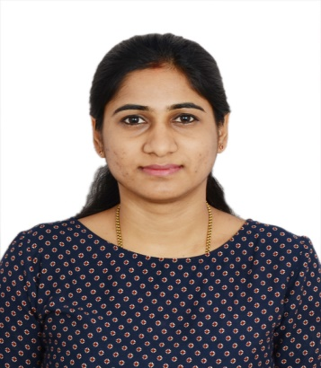
RAKSHITHA
Email : rakshitha.388144@2freemail.com

Career Objective:

To secure a challenging position with a professionally managed group which will utilize my knowledge and planning skill toward the betterment of the organization and provide me the opportunity for professional and personal growth.

Work Experience:

Muktha TV, The Unit of Yashashvi- creation Pvt LTD, Udupi
Duration: 25 October 2012 to 30 November 2013
Job title: Assistant Accountant

JOB RESPONSIBILITIES
- Review/ Preparation of daily journal vouchers for all expenses and all supporting documents.
- Maintaining cash book

Mysore Sales International Limited, Bangalore, India
(Sub Div: Chit Fund Department)
Duration: 06 February 2014 to 31 January 2016
Job title: Cashier and Document scrutinizer

JOB RESPONSIBILITIES
- Managing Administration of the office and deal with basic accounts
- Managing all employee documents/files in a standard manner according to the company policy
- Ideas are given for improvement of the branch like – Promotions, marketing, customer support etc.
- Worked as cashier and document scrutinizer
- Involved in the reconciliation of cash/accounts in the branch
- Customer support is the utmost priority and
- Ensuring quick turnaround time/support for customers.
- Managing all the financial transactions, tracking details before considering any case
- Timely manner of cash disbursement/ transactions being held at the branch
- Compliance and security checks before any consideration/ disbursement from the branch to customers
- Marketing and training conducted for new joiners

Empower Consultants Bangalore
Duration: 01 March 2016 to 08 December 2018
Job title: Admin Executive

JOB RESPONSIBILITIES

- Provide general administrative and clerical support including mailing, scanning, faxing and copying to management
- Maintain electronic and hard copy filing system
- Open, sort and distribute incoming correspondence
- Perform data entry and scan documents
- Manage calendar for Managing Director
- Assist in resolving any administrative problems
- Run company’s errands to post office and office supply store
- Answer calls from customers regarding their inquiries
- Prepare and modify documents including correspondence, reports, drafts, memos, and emails
- Schedule and coordinate meetings, appointments and travel arrangements for Managers
- Maintain office supplies for department

Qualifications

- Bachelor Degree in BA from St. Philomena College Puttur, Mangalore University, Mangalore, Karnataka with First Class in 2012.
- Pre-University Education from Government PU College Kadaba, Karnataka with First Class in 2009

Technical skill:
- Post Graduation Course Diploma In Computer Application (1 year Course)

Professional Skills:

- The Basic operation in Microsoft Word, Excel, PowerPoint
- Planning and Managing internal & external activities
- Initiative and creativity
- Positive attitude
- Teamwork and collaboration Accounts payable / accounts receivable
- Mail handling
- Staff management in Business administration

Personal Details:

Date of Birth : 26th March 1991
Nationality : India
Marital Status : Married
Language Know : English, Hindi, Kannada, Tulu

