NAWAID

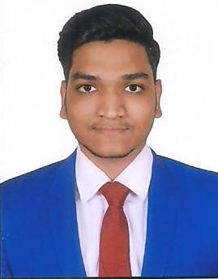

Email: nawaid.388162@2freemail.com

OBJECTIVE:

To work in a globally competitive environment on challenging assignments that shall yield the twin benefits of the job satisfaction and to start my career by joining a well settled and highly professional organization

EDUCATION:

Bachelor of Technology in Computer Science Engineering Nov 2017
VIF College of Engineering &Technology, Hyderabad, India
Percentage: - 65%

Intermediate March 2013
Sultan-ul-uloom Junior College, Hyderabad, India
Percentage: - 60%

Secondary School Certificate March 2011
Loyola High School, Hyderabad, India
Percentage: - 61%

TECHNICAL SKILLS:

Microsoft Technologies | C#.Net, ASP.Net, ADO. Net, WCF,LINQ
Web Technologies | HTML,XML
Scripting Languages | Javascript, Jquery
Operating Systems | Windows, Mac
Database | SQL Server 2005/14, MySQL
Web Servers | Internet Information Server (MS-IIS 6.0)
IDE | Visual Studio 2005/17

EXPERIENCE:

Worked as a Dot NET Software Developer for A J Technology Resources, Hyderabad from Nov 2017 to Jan 2019.

PROJECT:

Title: “Protecting Application Against Piracy”.
Environment: C#.NET, ASP.NET, Web Services, SQL Server 2005
Team Size: 8
Client: Data point Info Solutions
Duration: January 2018 to November 2018
Description: To avoid the Piracy or illegal usage of application, we like to build Software which can maintain & monitor The Licenses. Through this Software the Organization will flexibly license all their software applications. The License Server project is having Web and Windows Environments.

Responsibilities:
- Involved in the Admin Module
- Implemented user interface using HTML, CSS and JavaScript
- Used Validation Controls in ASP.Net for validating Front-end form
- Extensively used Grid Views with sorting and paging
- Involved in the all Phases of Software Development Life Cycle like Requirements Gathering, Analysis, Design, Implementation and Testing.
- Used N-tier architecture for presentation layer, the Business and Data Access Layers and were
Coded using C# .Net

CERTIFICATIONS:

- Certified Trained in C Programming from NIIT-Hyderabad.
- Certified Trained in .NET from NARESH IT-Hyderabad.
CO-CURRICULAR ACTIVITIES:
- Organized National Cloud Computing Workshop, Hyderabad 2014
- Organized National Ethical Hacking Workshop, Hyderabad 2016
- 1st Place in KG Reddy Cricket Tournament: Inter-college Championship, 2016.
- 1st Place in SUJC Inter-collage Cricket Championship
- 1st Place in Loyola High School Carrom Championship, 2011.
- Social Welfare Activities.
PERSONAL DETAILS:

Marital Status : Single

Language Known : English, Hindi & Urdu

Nationality : Indian

