Maryam
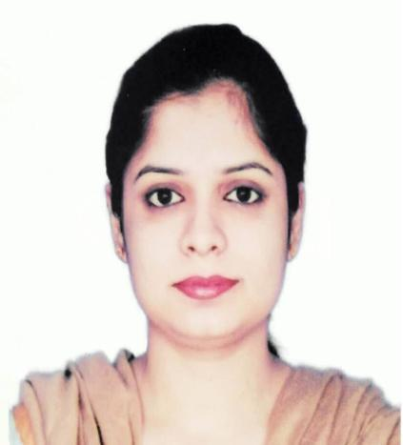
Human Resource Management Professional

Email: maryam.388163@2freemai.com

- Qualified and experienced HR professional with blend of academic credentials, analytical agility & relentless enthusiasm towards human resource management procedures, policies implementation, training and development activities

- Performance-oriented professional having ability to manage multiple projects. Capable of initiating collaboration at all levels of organization, rendering participation in administrative tasks, monitoring attendance timings and maintaining salaries records

- High-performing and dedicated team player who can deploy participative management style in fast-paced corporate environment with diverse workforce to drive goal-oriented performance & can imply process improvement techniques

CORE STRENGTHS & ENABLING SKILLS
▪ | Human Resource Management | ▪ Performance Appraisal & Conflict Management |  | ▪ | Training & Development
▪ | HR Policies Execution | ▪ | Customer Risk Profiling & People Management | ▪ | Business Communication
▪ | Strategic Succession Planning | ▪ | Employee Relation Management | ▪ | Interpersonal Skills

PROFESSIONAL EXPERIENCE

Jotix Technologies, Lahore, Pakistan
Worked as “HR Officer”, October 2014 – November 2018
Responsibilities/Accomplishments:

- Effectively participated in customer relationship, recruitment and logistics enhancement projects. Managed procedures of compensation, benefits, employee orientation, employee development and training activities

- Expertly handled orientation and documentation for department. Provided support in recreational activities for organization; periodically reported to department Manager

Key Achievement:
- Successfully established and managed co-working space while generating leads

PROFESSIONAL QUALIFICATIONS

- Virtual University, Lahore, Pakistan (2009 – 2011)

MBA – Human Resource Management

- Govt. Gulberg College, Lahore, Pakistan (2007 – 2009)

B.Sc – Computer Science

