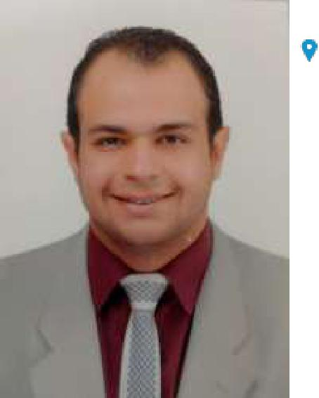

Hassouna.

Email: hassouna.388176@2freemail.com

| Nationality Egyptian.

Marital status Single.

July 2011 – Sep 2011

July 2012 – Sep 2012

July 2013 – Sep 2013

July 2014 – Sep 2014

July 2015 – Sep 2015

July 2016 – Dec 2016

Jan 2017 – Mar 2017

April 2017 – June2018

June2018– Nov2018

June2018– Jan2019

EDUCATION AND TRAINING

Class of 2015 – 2016

PERSONAL SKILLS

Veterinarian Assistant at Al-Obeikan local vet pharma (Taif area)

Veterinarian Assistant at Al-Obeikan local vet pharma (Taif area)

Veterinarian Assistant at Al-Obeikan local vet pharma (Taif area)

Veterinarian Doctor at Al-Qurshy local pet clinic (Makkah area)

Veterinarian Doctor at Al-Qurshy local pet clinic (Makkah area)

Veterinarian Surgeon at local pet clinic (part time)

Medical Rep at Omega Company

A veterinary Practitioner and surgeon in the Quarantine Unit and the Feeding of Calves Project in the Egyptian Armed Forces

Medical Rep at Pharco pharmaceutical Company .

Veterinarian Surgeon at pet clinic (American Veterinary Centre) Emergency line.

Bachelor of Veterinary Sciences

Faculty of Veterinary Medicine Suez Canal University

Mother tongue(s) | Arabic
Other language(s) | English (good)

Digital competence :

ICDL Certificate

