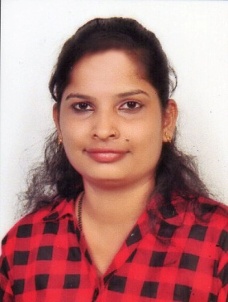
ASHWINI
Email: ashwini.388206@2freemail.com

Civil Status : Married
Sex : Female

ACCOUNTANT
PROFESSIONAL EXPERIENCE OF OVER THREE YEARS
Objectives Career:-
To seek a challenging, progressive career industry involving a comprehensive teamwork and sincerely serve the organization through dedication, hard work and optimization of my technical skills.
Area of experience :-
- Accounts
- Billing
- Taxation
- Stock maintains
- Day book maintains
- Balance sheet
Computer Skills: -
- Proficient in MS Office application (Excel and Word)
- Tally ERP.9
- Computer Literate
- Computer Knowledge
Academic qualification :-
- Passed Bachelor of Science (B.sc) examination from University of Mangalore in 2018
- Pre degree in science at PU Board Karnataka of India
- Secondary School education in Karnataka State board of India
Language Knowledge:
- English
- Kannada
- Malayalam
- Tulu
Working Experience:-
- Organization : Agrimart ( Saya Enterprises Mangalore)
Organisation type : Agricultural equipment services Mangalore
Designation : Accountant/Office Assistant
Tenure : 2015 -2018
Achivements : Reliable and trusted office Assistant
Job description :
I have worked as receptionist at office exhibition stall. I was handling at billing section and also stock maintains.
- Organization: KVG medical College and Hospital( Sullia Mangalore)
Organization type: Medical College and Hospital
Designation : Receptionist/ office assistant
Tenure : February 2018 – January 2019
Job description :
I was worked at billing section and I also handled medicine stock department.

