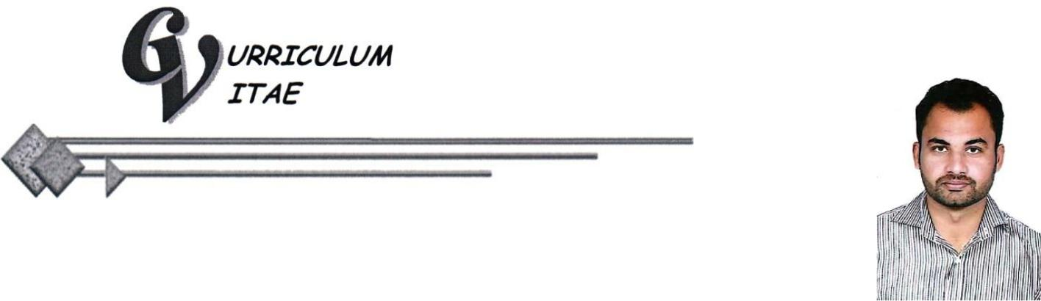

INTISAR

Email: Intisar.388223@2freemail.com

CAREER OBJECTIVE:

- To join an organization where I can learn and polish my skills and also prove myself as a proficient and vigilant Civil Engineer and where I can get more opportunities for better future.

PROFESSIONAL EXPERIENCE:

(05 Years Exp. in Civil Sub Engineering Industry & Supervision)

CAREER HISTORY:
EMPLOYER |  | Local GOVT & CD Depptt. Civil Sub Division, Punjab
• | Position Held |  | : | Civil Supervisor
• | Period |  | : | 28 july 2017 to 27 july 2018.
• | Description of Duties |  | : | I worked as Civil Supervisor for

- Performing layout according to drawings. Construction supervision of Brick Masonry, Reinforcement and form work of lintels, beams, columns, shuttering & reinforcement of roofs etc.

- Construction supervision of finishing works like plaster, cladding and Tile work.

- Construction supervision of flooring, Road sector, Drainage work etc.
EMPLOYER |  |  | Sunnestco (Pvt.) Ltd.
• | Position Held | : | Civil Supervisor
• | Period | : | 08 August 2015 to 01 July 2017.
• | Description of Duties | : | I worked as Civil Supervisor for

- Construction supervision of Structure work of building at Lahore (Bahria Town).

- Construction supervision of Boundary wall work of Pakistan railways at Gujranwala & Wazirabad.

- Performing layout according to drawings. Construction supervision of Block work, Reinforcement and form work of beams, columns, shuttering & reinforcement of slabs.

- Preparation and verification of Sub Contractor Bills.

1

EMPLOYER |  |  | SESCO (Pvt.) Ltd.
• | Position Held | : | Sub Engineer
• | Period | : | 01 August 2013 to 15 June 2015.
• | Description of Duties | : | I worked as Sub Engineer for

- Construction supervision of Building Constructions and Maintenance works,

- Drains Constructions and Maintenance works, Stone pitching works,

- Performing layout according to drawings. Construction supervision of Block work,

- Telecommunication Towers foundation Construction and Towers Erection Works for Different Clients like PTCL, Punjab Irrigation Department Project at Head Khanki.

QUALIFICATION:

Matriculation (B.I.S.E. Gujranwala)

• 2010 (Year)

- 720/1050 (Marks)

C.C.A ( Govt of the Punjab (Tavta)

• | 2010 | (Year)
• | 62% | (Marks)

Auto CAD Operator ( Pvt.)

• | 2013 | (Year)
• | 81% | (Marks)

D.A.E Civil (P.B.T.E. Lahore)

• 2013 (Year)

- 2352/3500 (Marks)

LANGUAGES KNOWN:

- Fluency in English, & Urdu.

INTERPERSONAL SKILLS:

- Team work spirit & motivation

- Energy enthusiasm and motivation to work hard

- Excellent communication skills

- Abilities to make other understand own viewpoint

COMPUTER SKILLS:

- Operating Systems: Windows-2000 / Xp.

- INPAGE, MS Word, MS Excel, MS P.Point, Internet Explorer, etc..

- Internet Browsing.

- AutoCAD 2D & 3D, 3d Max.

- Computer Software & Hardware.

2

