SHIBIN
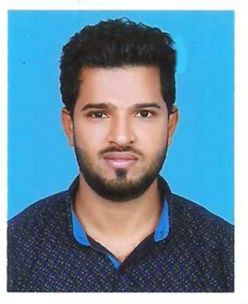

Email: shibin.388231@2freemail.com

Position applied for: Site Engineer/Junior Engineer/ Site supervisor/ Quantity surveyor

CAREER SUMMARY

Dedicated Civil Engineer with 2 years of experience and success in all phases of Engineering operations. Capable of overseeing and guiding construction process from ground to finish. Experienced in site operations of multi-storied framed concrete structures and pile foundations. Well versed in AutoCAD 2D drafting and Quantity Surveying.

EDUCATION

B.Tech in civil Engineering | 2016
Under Kerala University, India
Diploma in Civil Engineering | 2013
State Board of Technical Exams, Kerala, India

WORK EXPERIENCE

Palakkottu Builders And Designers

Site Supervisor

(May 2018 to November 2018)

A leading construction Company in Kerala, India - Supervised the construction of 110KV Electrical Substation Building in Trivandrum, Kerala, India

Major job responsibilities

- Managing a team of skilled and unskilled labours, overseeing their day to day activities.

- Keeping records of the daily progress of work and the materials at site.

- Quantity analysis and ensuring the timely receipt of materials.

- Preparing bar bending schedule and bill of quantity.

- Ensuring that the work is going on as per the given drawings and specifications.

- Dealing with subcontractors and resolving any arising conflicts.

Achievement- Played a key role in the completion of work within the given time.

Travancore Pile Foundations

Site Engineer

(August 2016 to March 2018)

A reputed company which deals with the construction of pile foundations, in Kerala, India. Major job responsibilities

•Ensuring that the piles are driven to the desired depth and strata as per the design specifications.

•Conducting various site tests such as pile load test, hydrometer test and sounding. •Maintaining the site accident free by regular awareness meetings and thorough implementation of safety measures.

•Preparing bore logs and keeping site records of individual piles

Achievement- Successfully casted 500+ piles using various methods, got promoted from Site Supervisor to Site Engineer in 8 months

PERSONAL SKILLS

- Resource Management

- Conflict Management & negotiation

- Communication

- Decision making

- Labour Management

COMPUTER SKILLS

- 1 year experience in Auto cad 2D Drafting and excellent Quantity Surveying skills

- Proficient in MS Excel.

PERSONAL DETAILS

Nationality | : | Indian
Marital Status | : | Single
Languages | : | English, Hindi, Malayalam, Tamil
IT Skills | : | AutoCAD, MS Office, MS Excel, Internet & E-Mail applications

