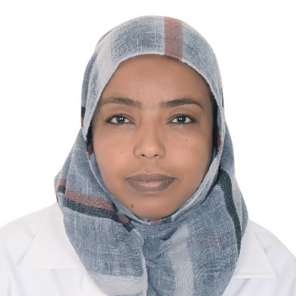

CURRICULUM VITAE
SANA
E-MAIL: sana.388248@2freemail.com
OBJECTIVE:
Aspiring for an optometrist in highly reputed organization that provides me an opportunity to bring my optometry knowledge and team work ability will help in serving the patients in need & satisfy them by dedicating myself fully to optometry.
PROFESSIONAL QUALIFICATIONS:
Bachelor of optometry and visual science –Alnelain University - Sudan.
Optometry license Details:
HAAD-ABUDHABI-UAE
DHA-DUBAI-UAE
Home license –SUDAN.
Language:
Arabic - English
PROFESSIONAL EXPERIENCE:
Al jaber optical- (UAE) from 25/10/2016 to 25/07/2018
Primary health Care_ (Ministry of Health SUDAN) from 15/9/2013 to 25/10/2016
Al waha Optical center- (SUDAN) from 2008 to 2013
OPTOMETRY COURSES:
Training course in A and B-scan. Ministry of Health- Sudan.
Training course in Fundus camera -ALJABER-UAE
Training course in the art of selling-ALJABER-UAE
Astigmatism- The complete picture - (J&J)-UAE
Eye Evaluation spherical contact lens fitting – (J&J)-UAE

